Software Project Development On

|  |
| --- |
| **Blood Bank Management System** |

In Partial Fulfilment of

**Bachelor of Computer Application (BCA)**



Gujarat University (2021-2022)

(Third Year Bachelor of Computer Application)

Project created by

GROUP NO: 22

Gayakwad Siddhant G. [Roll No : 22]

Satodiya Shrey. [Roll No : 70]

Sharma Harsh. [Roll No : ]



Lokmanya College Of Computer Application (LCCA)

Shivranjani Cross Road, 132 Feet Ring Road,

Satellite, Ahmedabad-3800008

Contact No:- (079)-26920259

College Certificate

**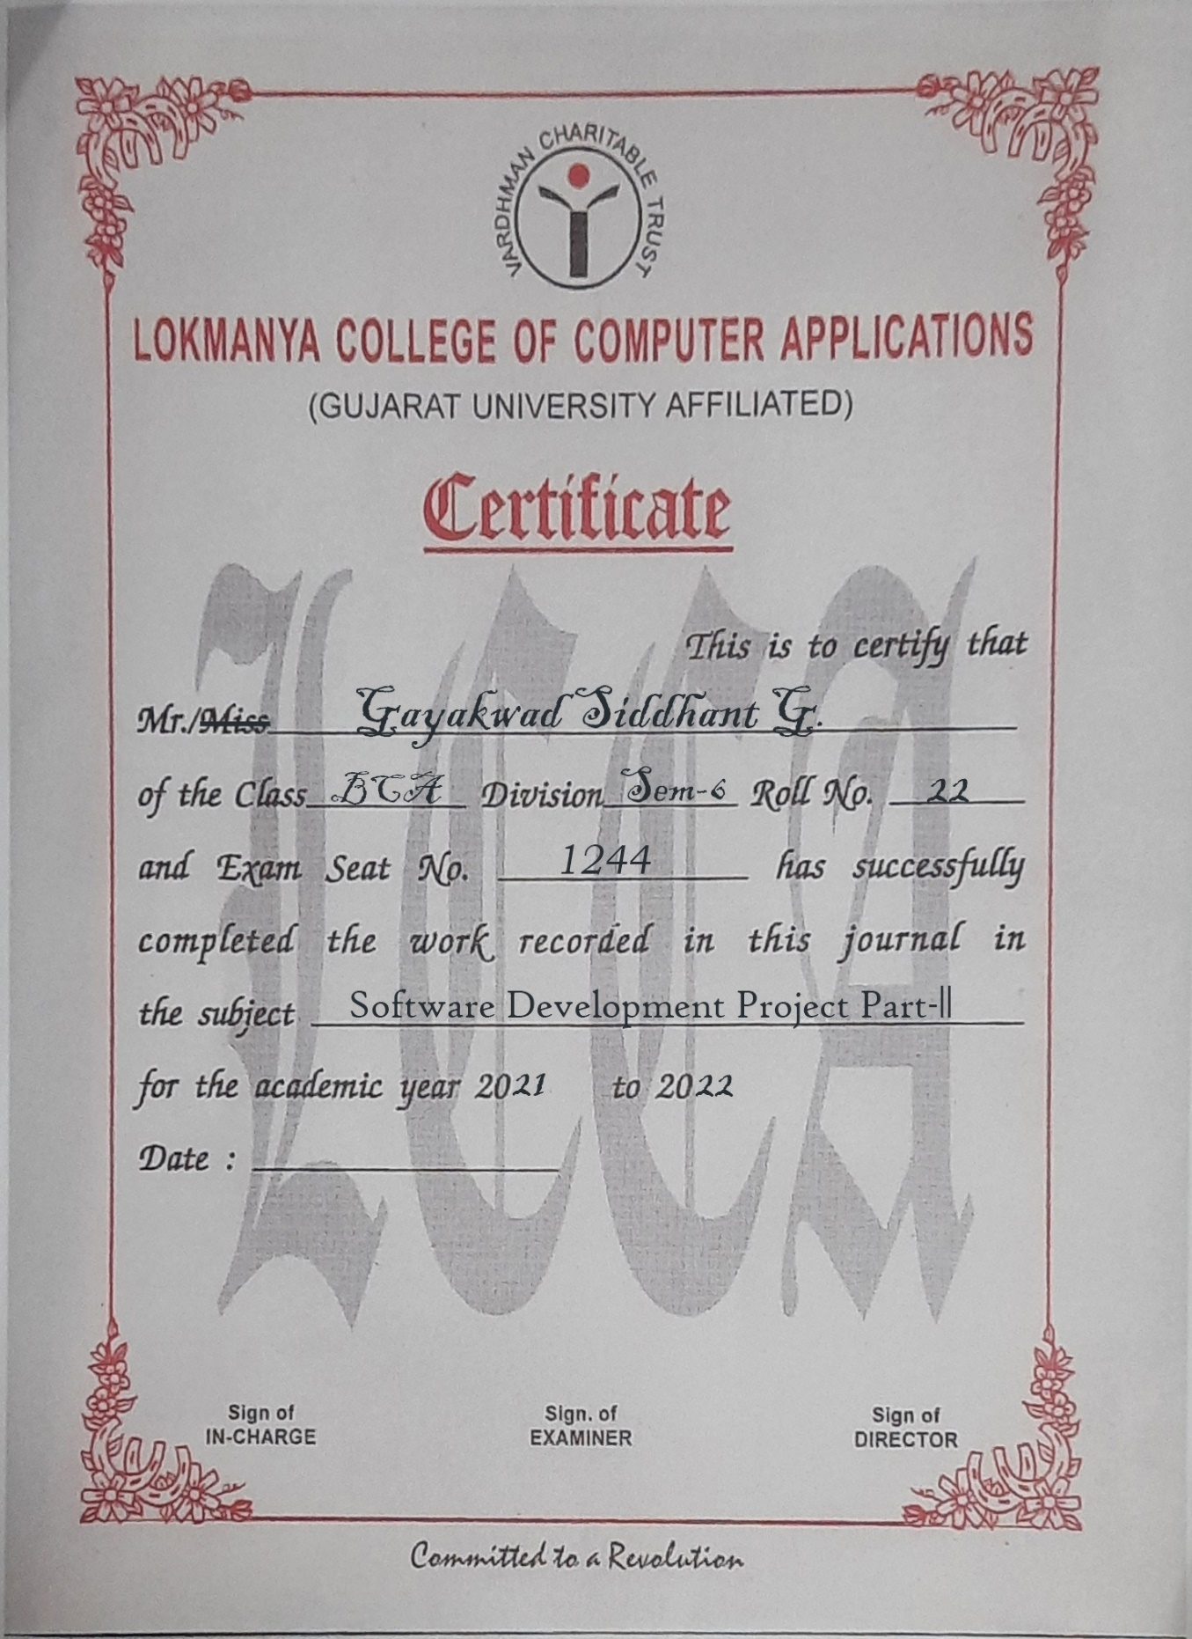**College Certificate**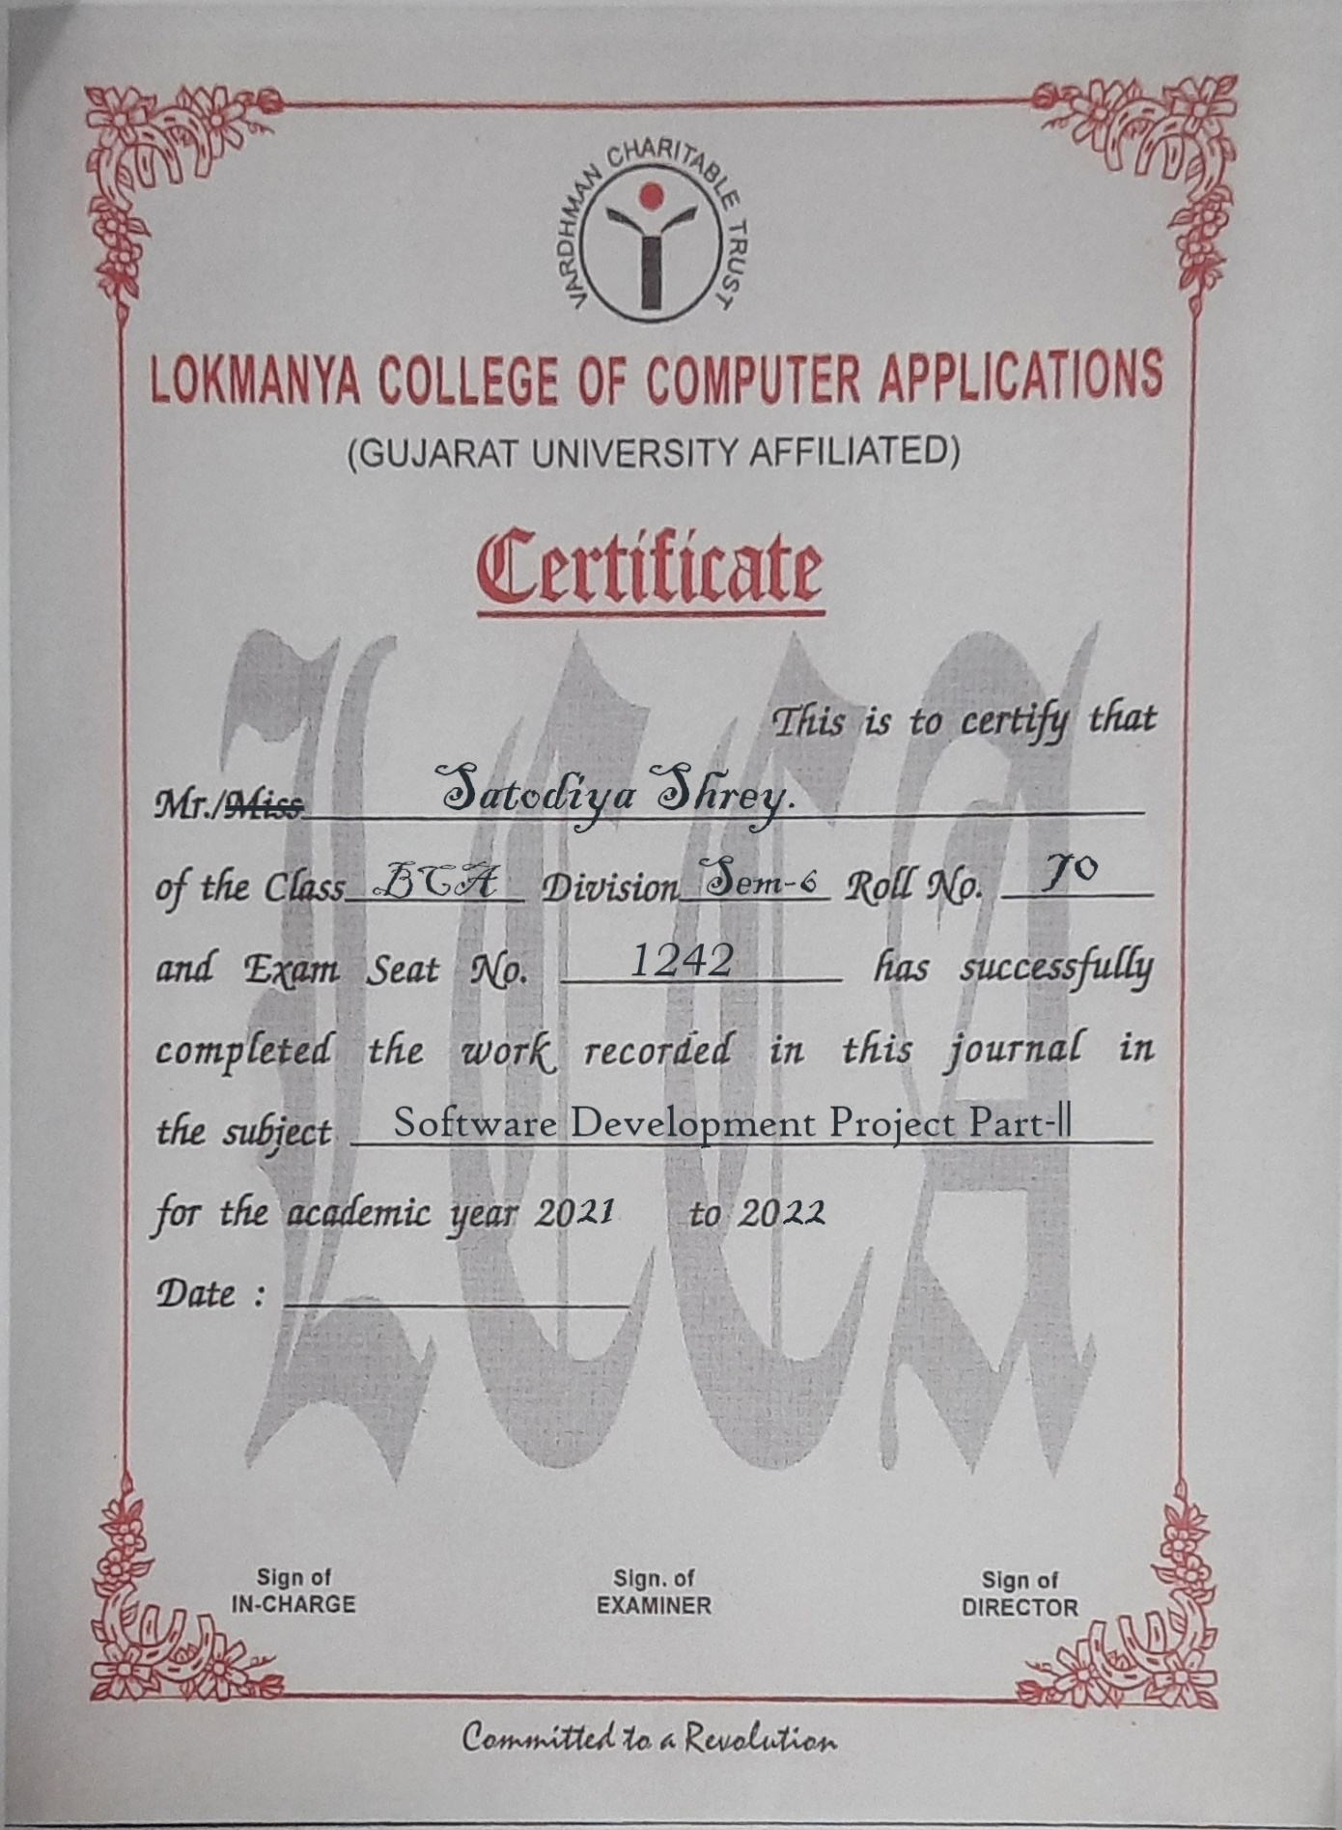**

College Certificate **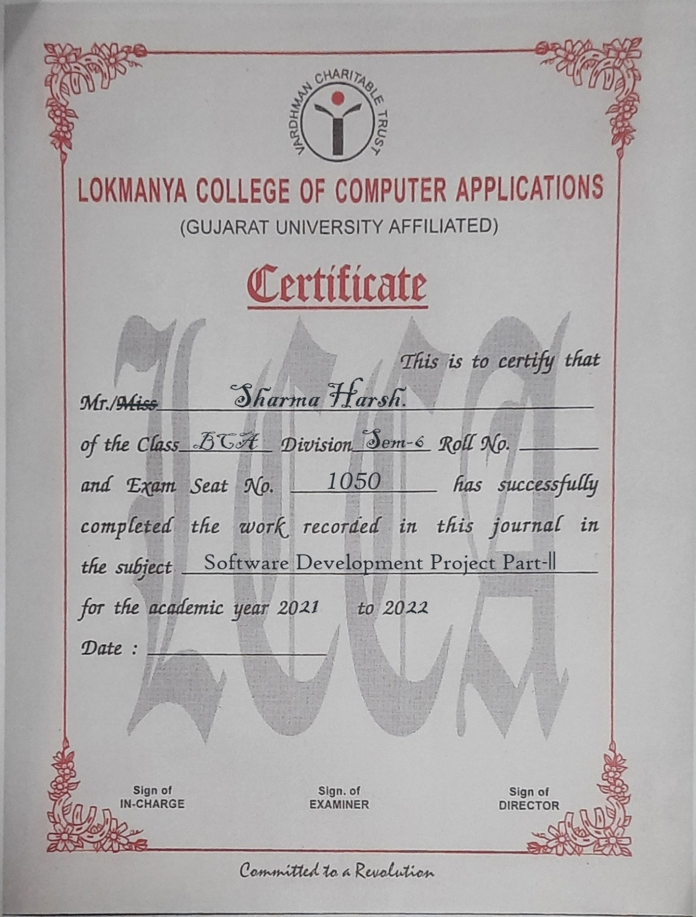**

**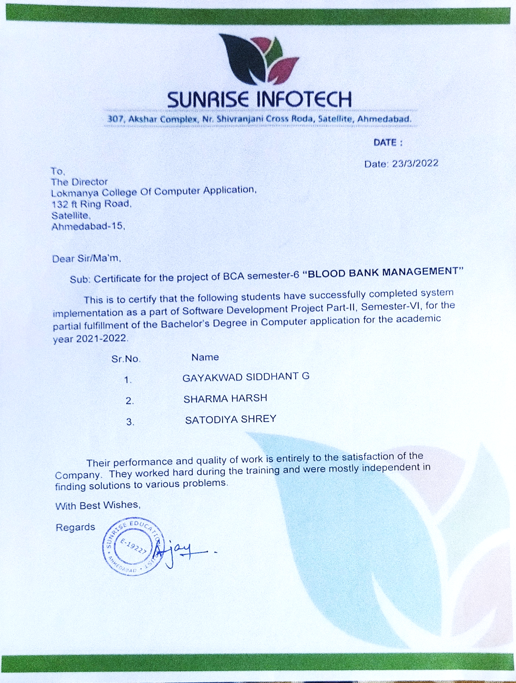COMPANY LETTER**

**ACKNOWLEDGEMENT**

* We did Bachelor of Computer Application project training in our Lokmanya college of Computer Application.
* We have sincerely graduated to college Prof. Sejal Vaghela (Project Guide) of Lokmanya College of computer application, Ahmedabad Providing this opportunity and necessary support during analysis of the project.
* We are also grateful to all staff members of this company for providing all technical assistance and helping for solving problems arising during analysis.
* We have no other words to express our sincere thanks to all ours lectures of Lokmanya College of computer Application, Ahmedabad for their kind co-operation and able guidance.
* We salute you all especially our Faculty Members our internal project guide in college and All Faculty Members who guides us in our projects.

**INDEX**

|  |  |
| --- | --- |
| **NO.** | **TOPIC** |
| **1** | **INTRODUCTION** |
|  | 1.1 Group Details |
|  | 1.2 Introduction |
|  | 1.3 Need for New System |
|  | 1.4 Tools and Technology |
| **2** | **LAYOUT** |
|  | 2.1 Screen Layout |
|  | 2.2 Report Layout |
| **3** | **FUTURE ENHANCEMENT** |
| **4** | **CONCLUSION** |
| **5** | **BIBLIOGRAPHY** |

**INTRODUCTION**



* The project blood bank management known to be a pilot project that is design for the blood bank together blood from various source & distribute is to the nearby people who have highly requirement for it.
* Management System motive at maintaining all the information related to blood donors, different blood groups available in each blood bank and help them manage in a better way.
* The software is designed to handle the daily transaction of the blood bank & search the detail when required.
* It’s also help to register have to blood collection as well as blood issue report.
* The software application is designed in such a manner that it can suit the need of all the blood bank requirement in course of future.

**ABSTRACT**

* The purpose of Blood bank data abstract php project study was to develop blood management information system to assist in the management of blood donor records and or control the distribution of blood in various parts of the country basing on the hospital demands.
* Without quick and timely access to donor records, creating market strategies of blood donor becomes very difficult.
* The blood management system offers functionality to quick access to donor records collected various parts of the country.
* It enables monitoring of the results and performance of the blood donation activity such that relevant and measurable objectives of the organization can be checked.

**PROJECT PROFILE**

|  |
| --- |
|  |

|  |  |
| --- | --- |
| **Project Title** | **Blood Bank Management System** |
| **Group Members** | Gayakwad Siddhant G.  Sharma Harsh.  Satodiya Shrey . |
| **Internal Guide** | All Faculty |
| **External Guide** |  |

**COMPANY PROFILE**

|  |  |
| --- | --- |
| **TITLE** | **DESCRIPTION** |
| **Company *Name*** | **Sunrise Infotech** |
| **Logo** | *IMG_20210820_161343.jpg* |
| **Development** | PHP, MY SQL SERVER |
| **Address** | 307, Akshar Complex, Nr.Shivranjani Cross Road, Satellite, Ahmedabad-15 |
| **Owner** | XYZ |
| **Web Site** | [www.sunriseinfotech.com](http://www.sunriseinfotech.com) |
| **E mail ID** | [SunRiseInfotech@gmail.com](mailto:SunRiseInfotech@gmail.com) |

**Tools & Technology**

|  |
| --- |
|  |

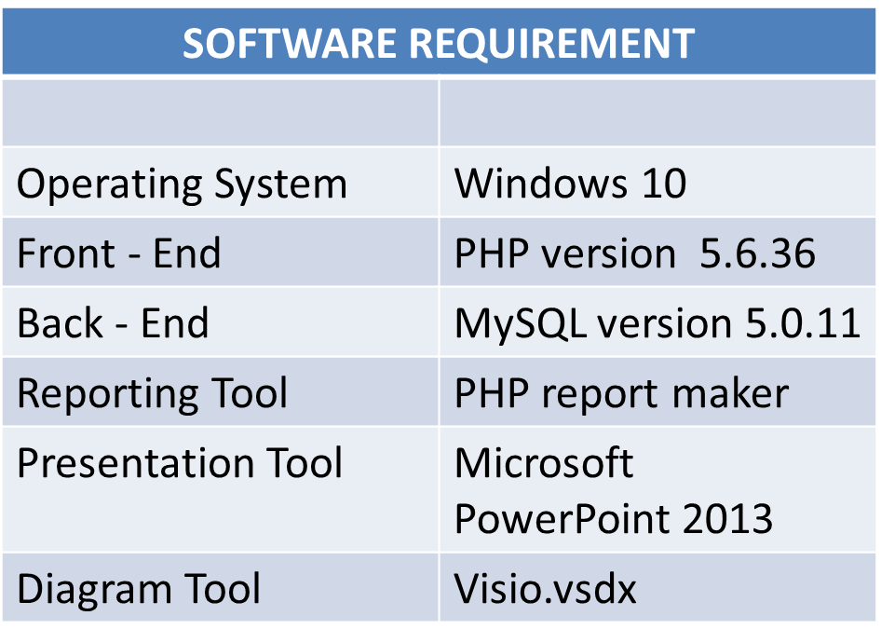

**EXISTING SYSTEM**

**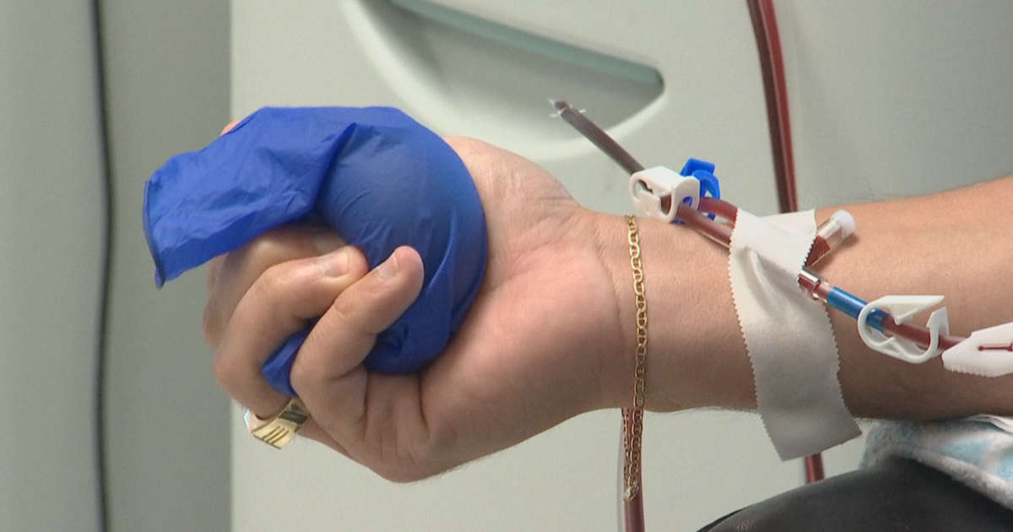**

* Time Consuming.
* Consumes lot of manpower to better results.
* It is a manual of the Needs and partially web Based.
* Difficult and Time Consuming to identify reliable one stop option.
* Lacks of data Security.
* Retrieval of data takes lot of time.
* Percentage of accuracy is less.

*USER*

*Home Page*

*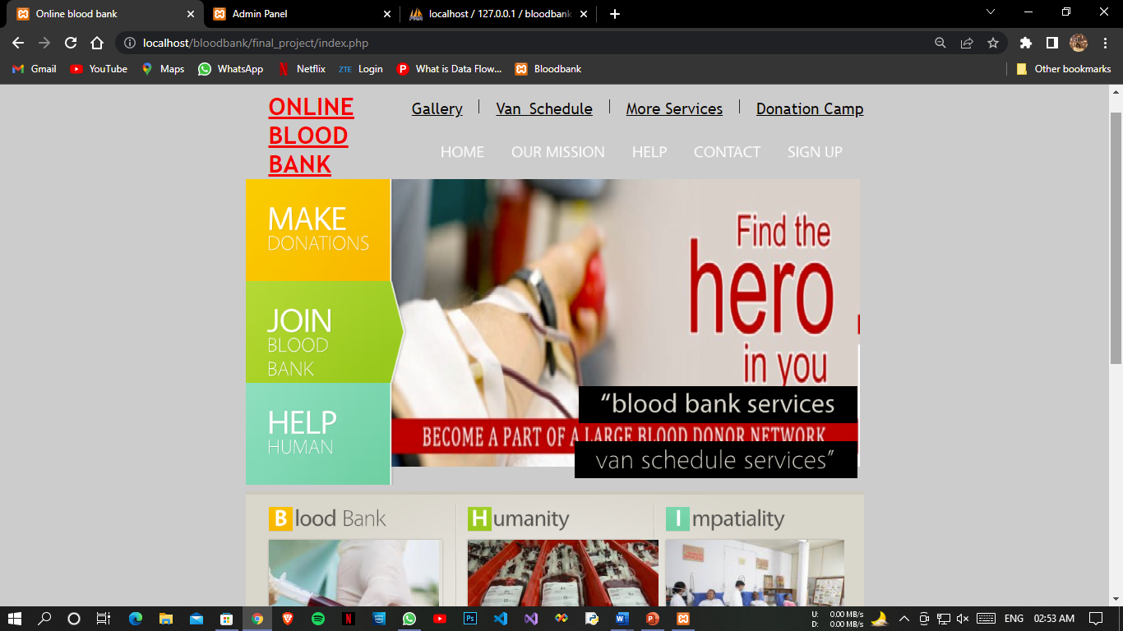Page 2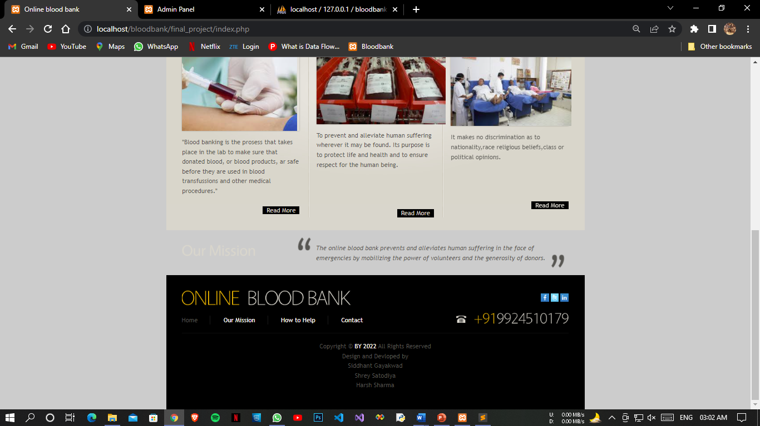*

*Our Mission*

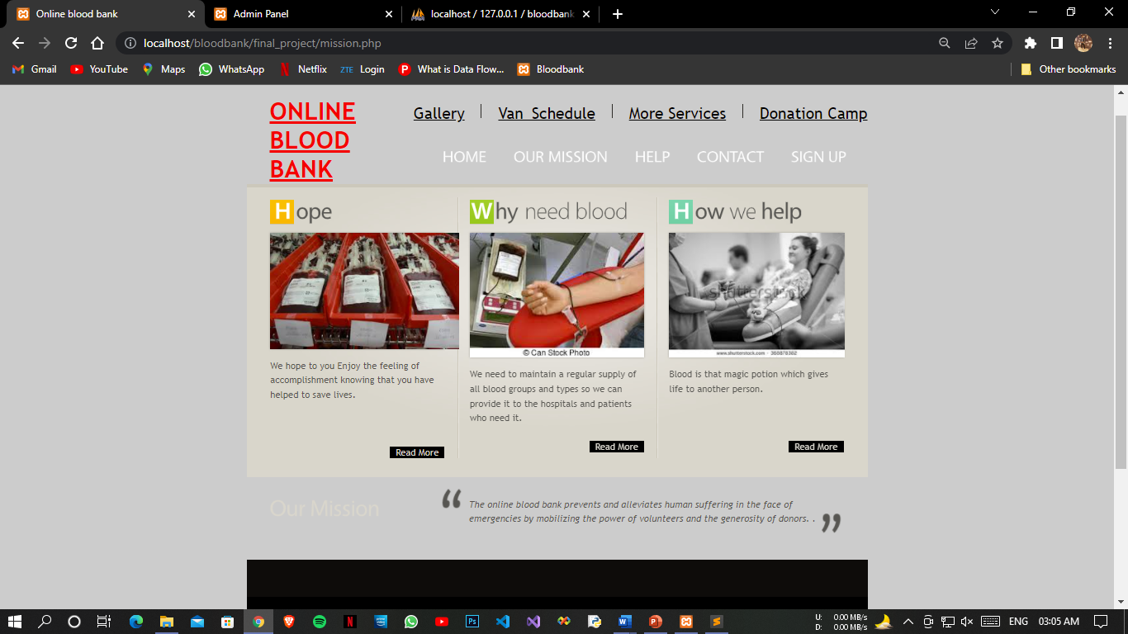

*Help Page*

*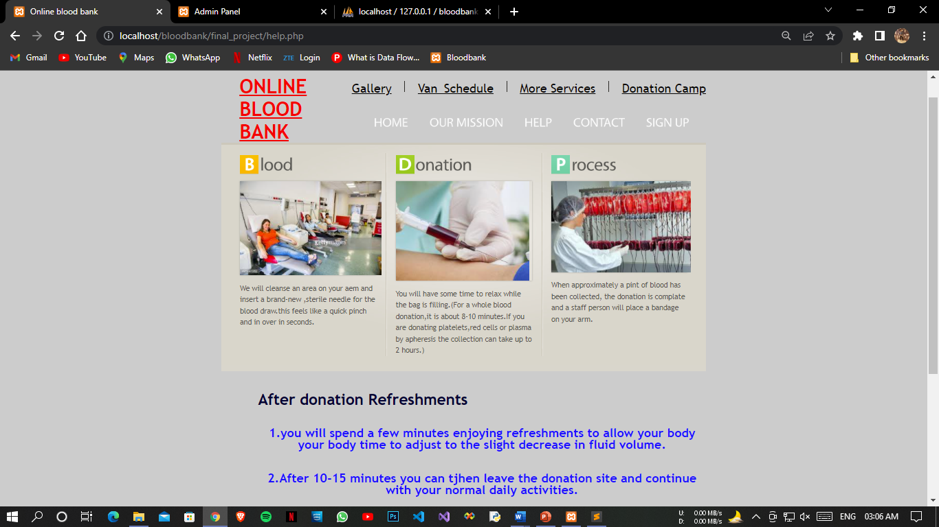*

*Registration Form*

*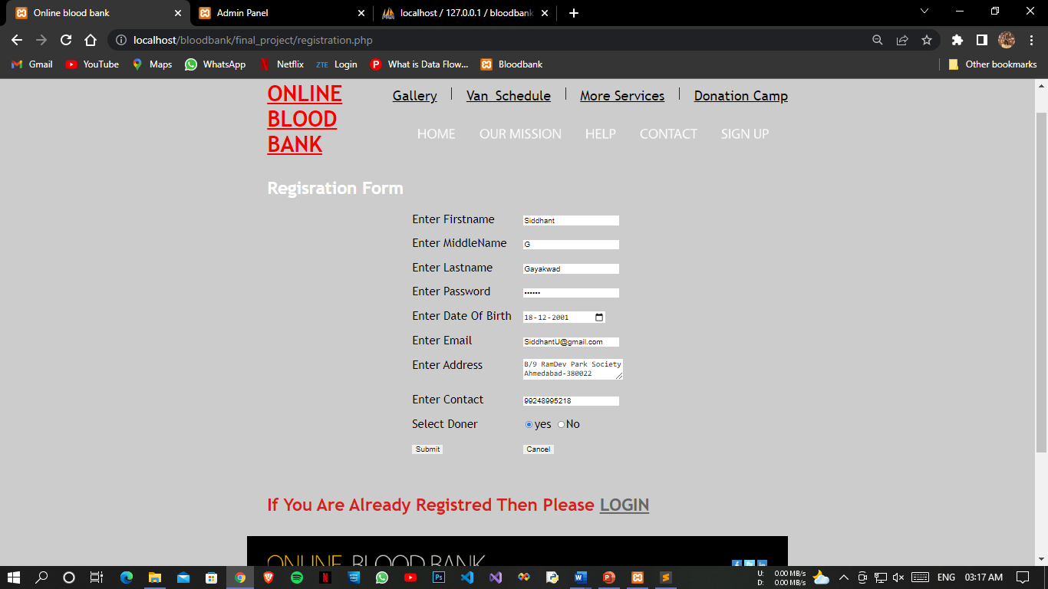*

*Login Validation Error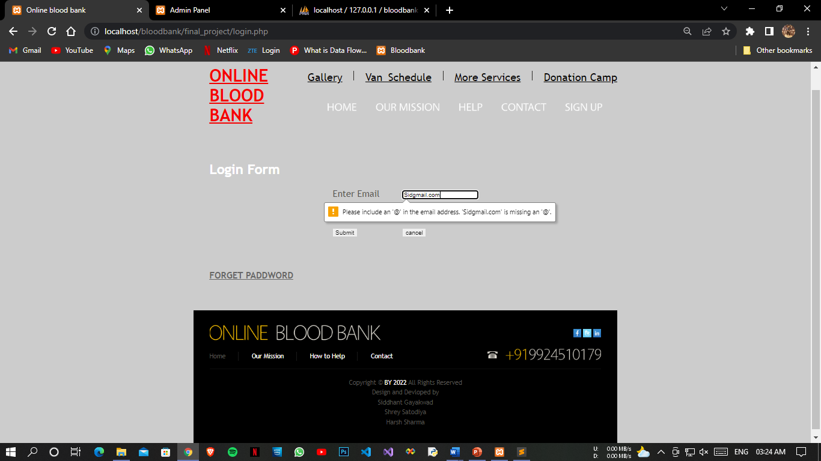*

*Login Error Page*

*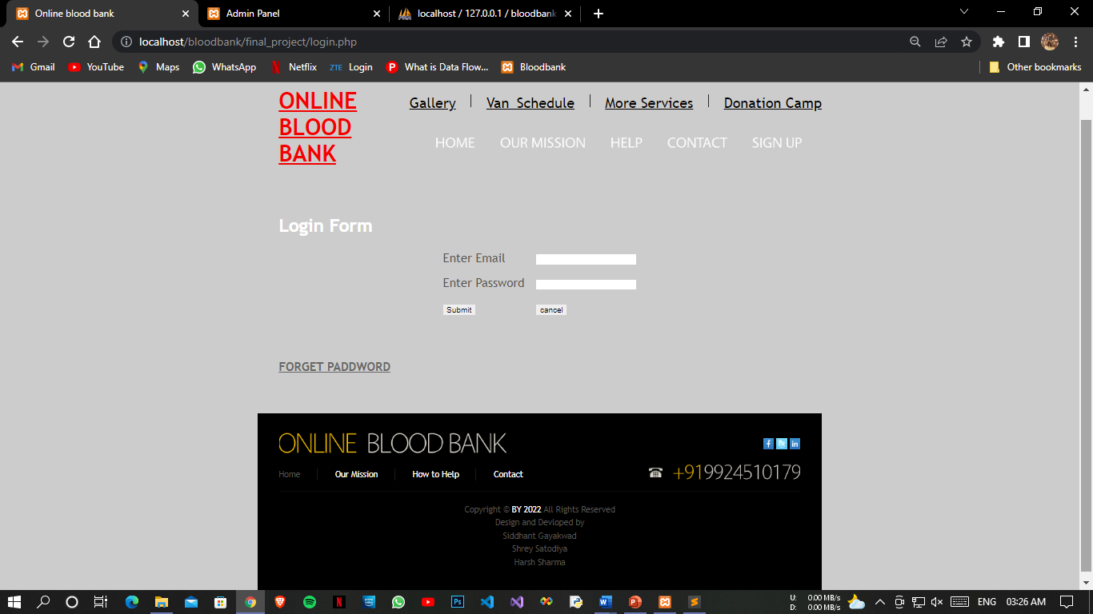*

*Registration Form Successful*

*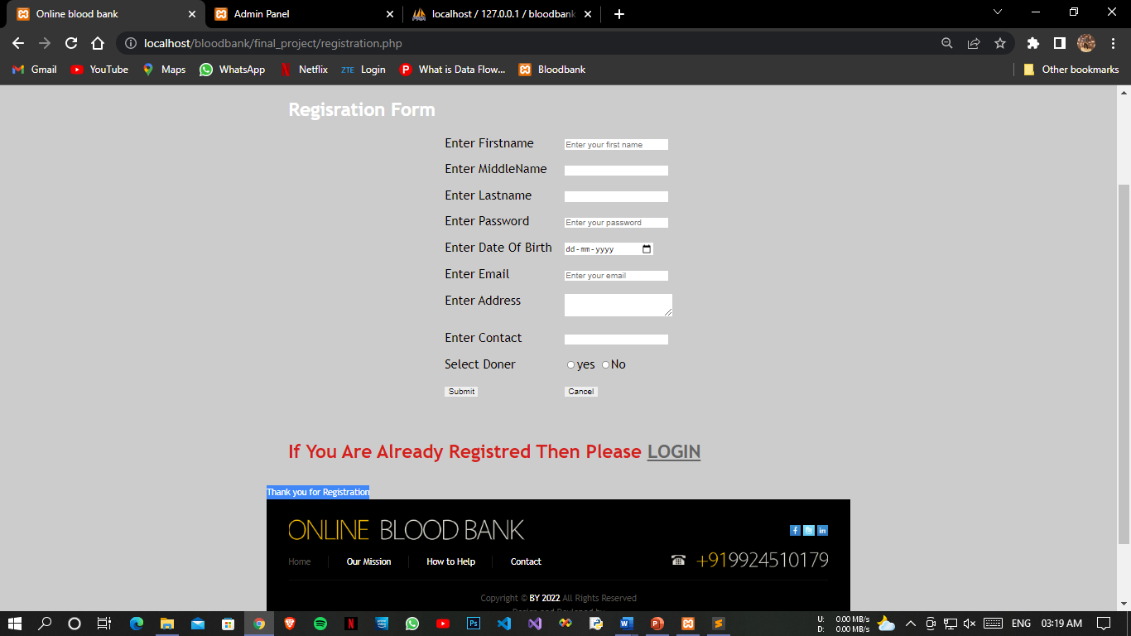*

*Password Forget Page*

*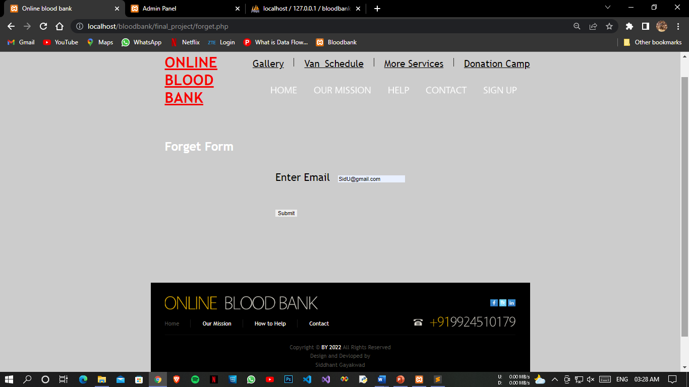*

*Forget Password Successfully page*

*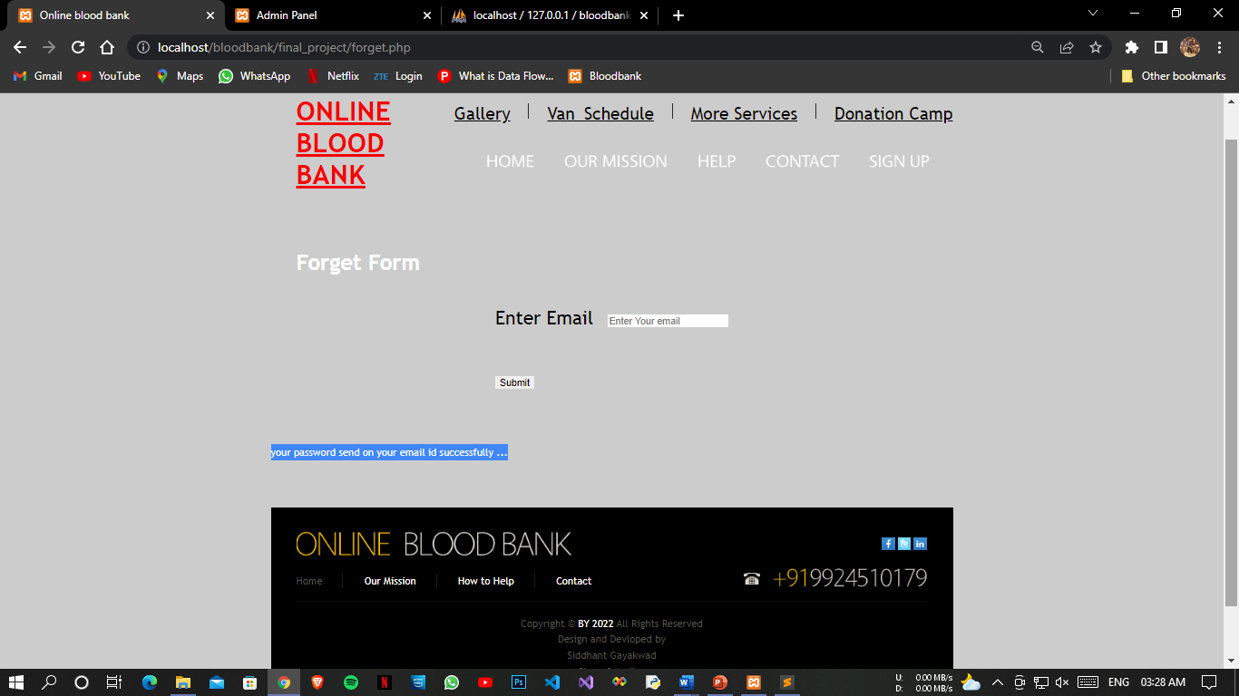*

*Login Page*

*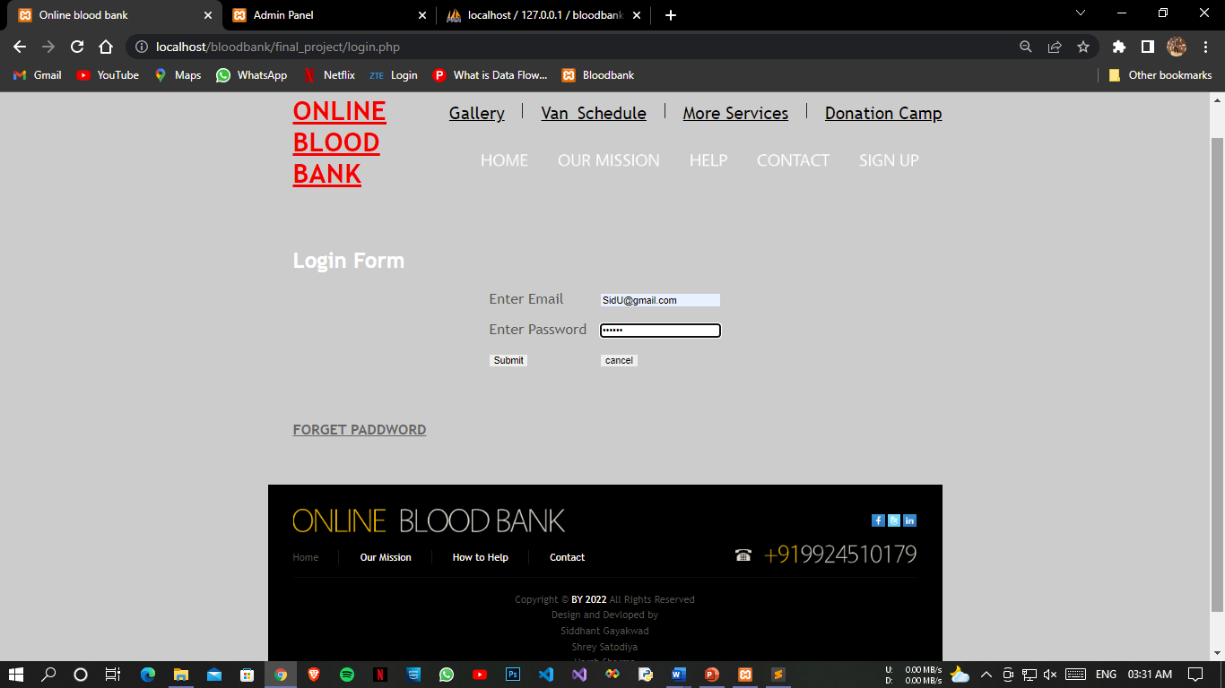*

*Login Successful Page*

*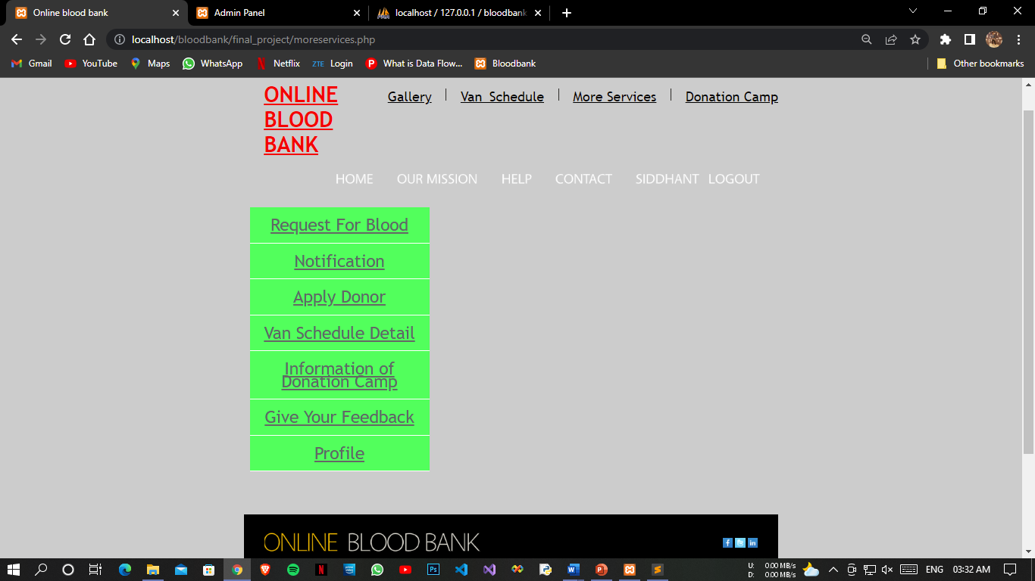*

*Gallery Page*

*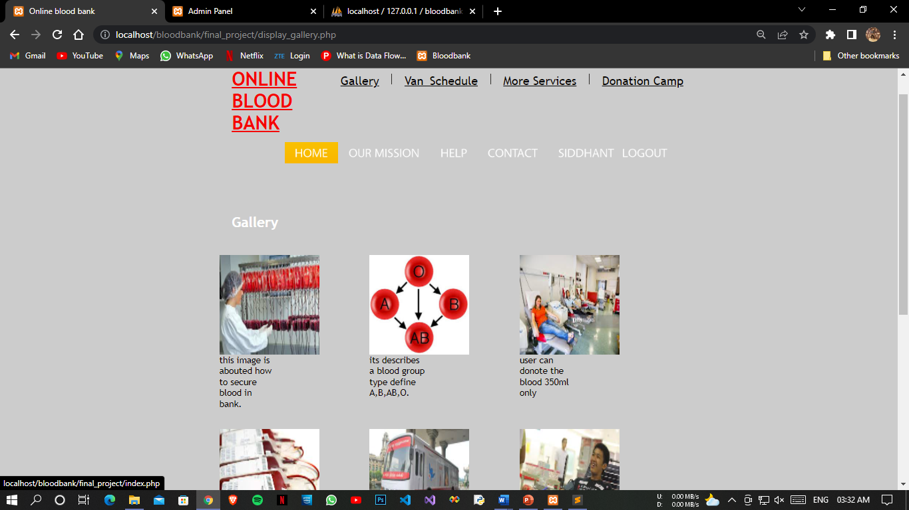*

*Gallery Page 2*

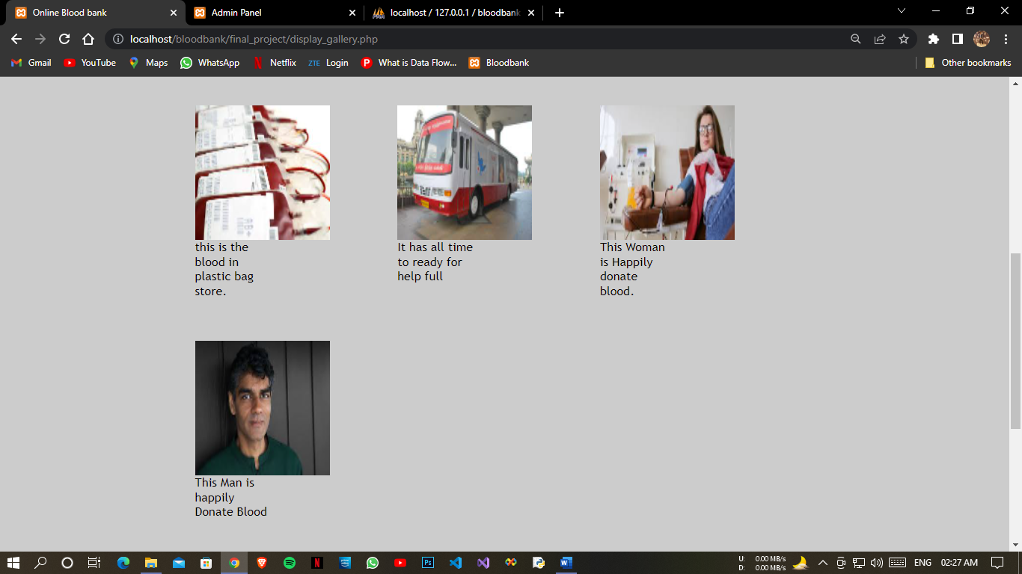

*Blood Request*

*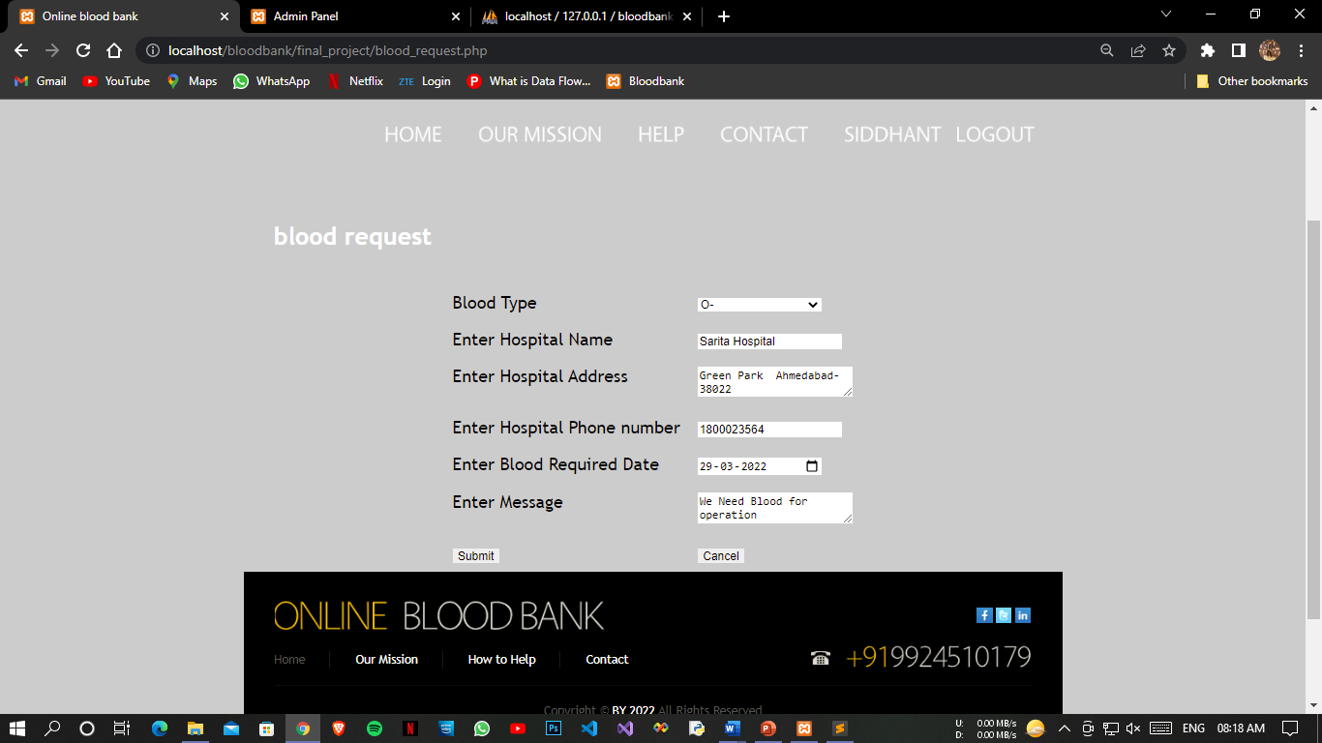*

*Successful Blood Request*

*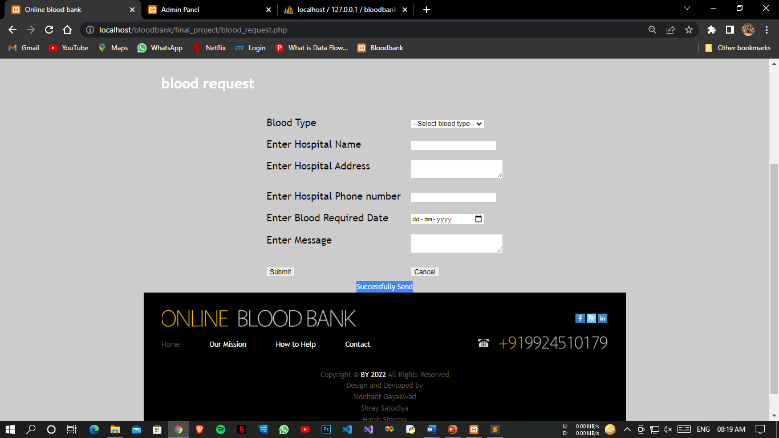*

*Notification*

*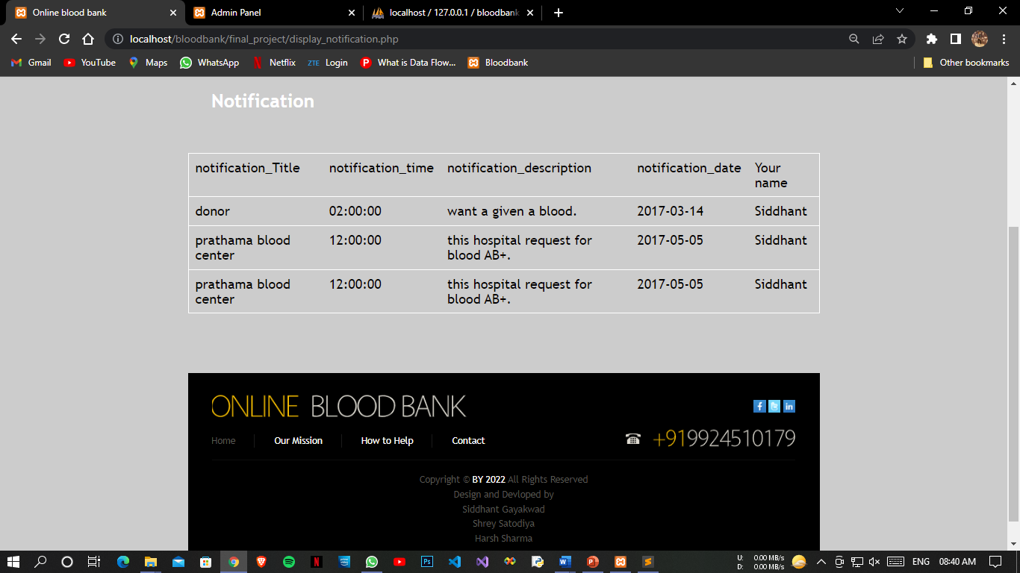*

*Apply for Doner*

*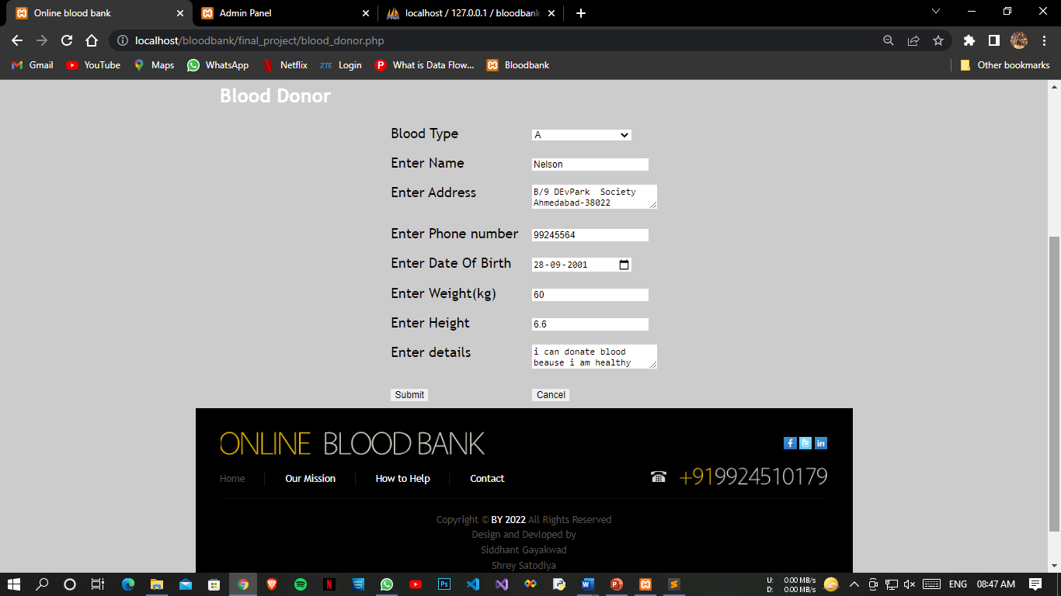*

*Successful Apply Doner*

*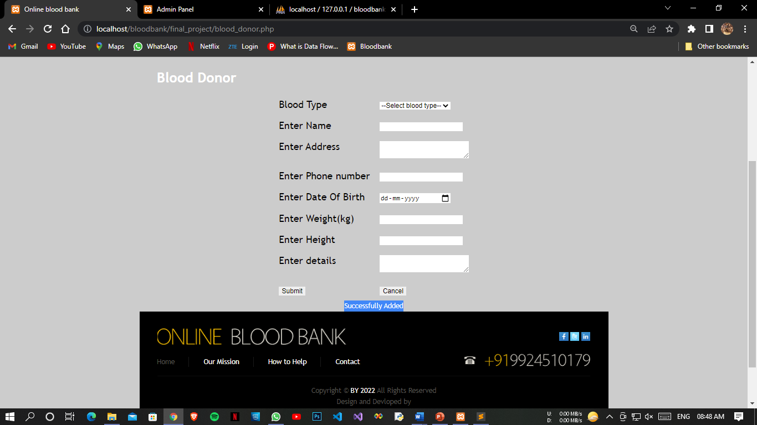*

*Van Schedule*

*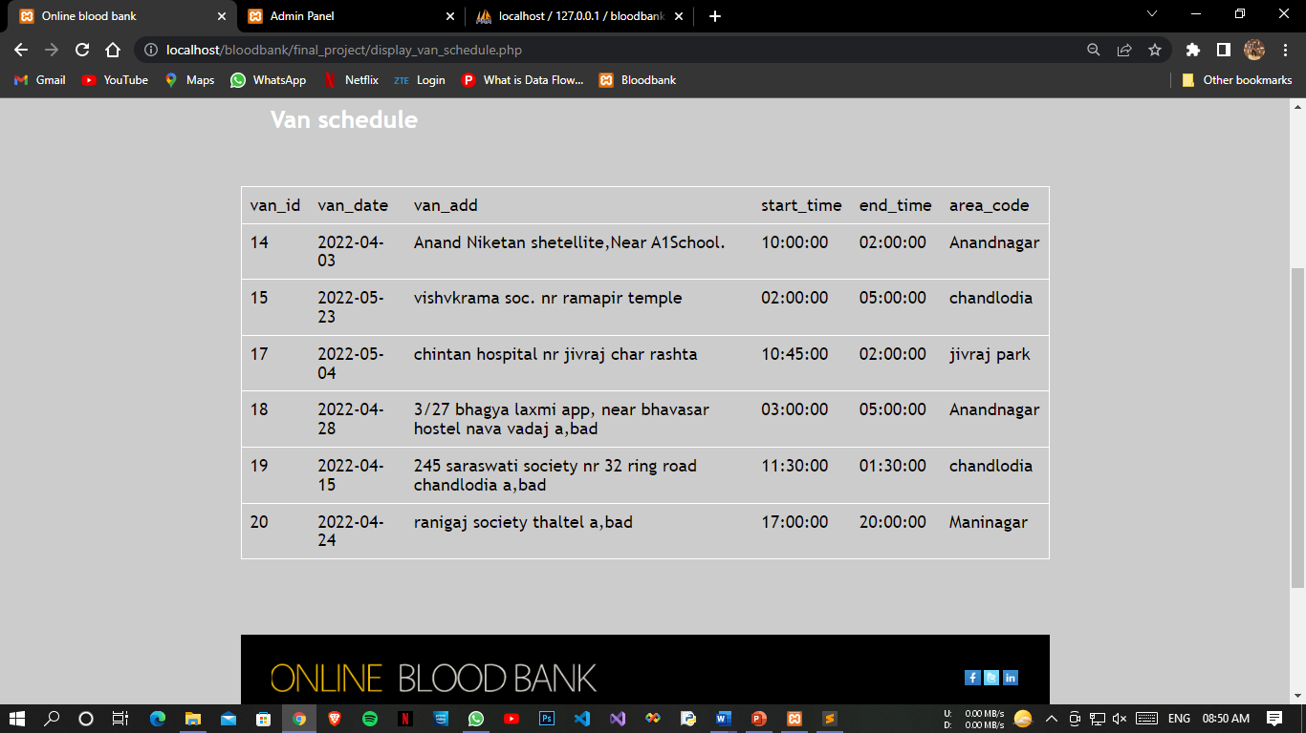*

*Donation Camp*

*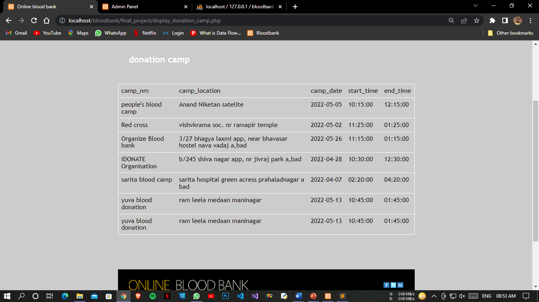*

*Feedback*

*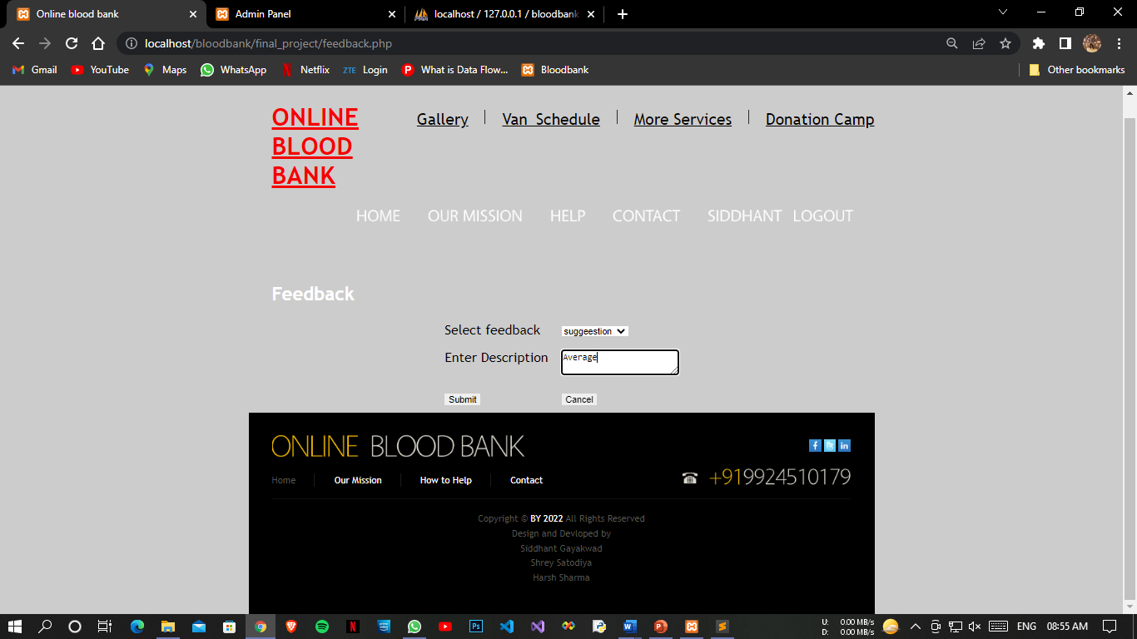*

*Feedback Successfully*

*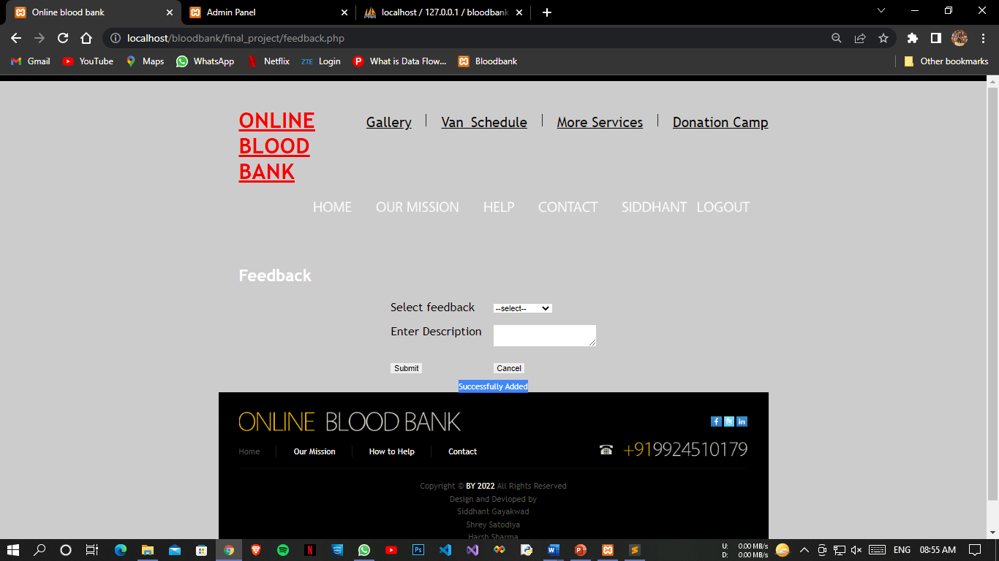*

*Profile Page*

*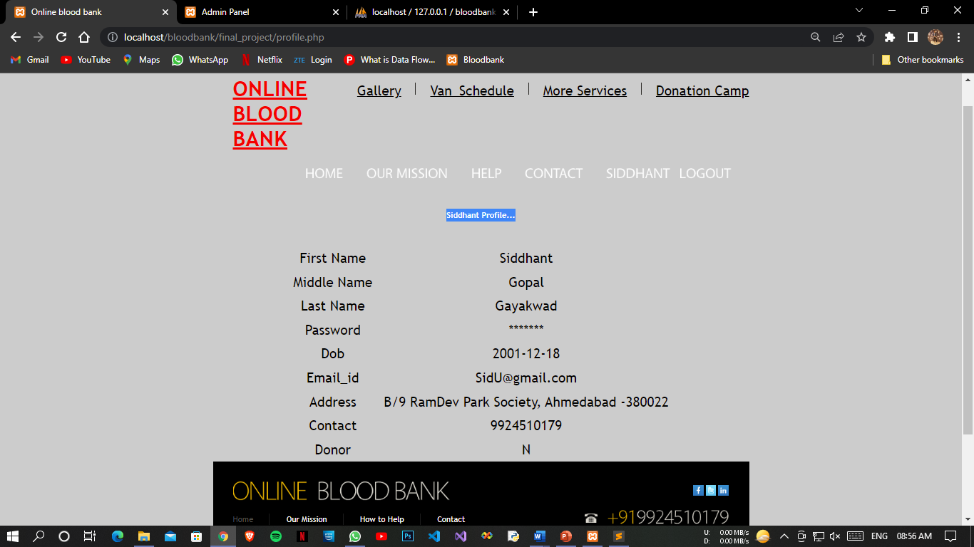*

*Contact Us Page*

*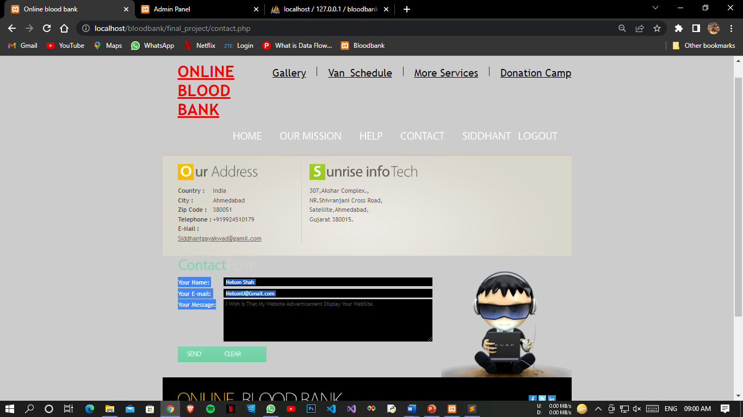*

*Logout Page*

*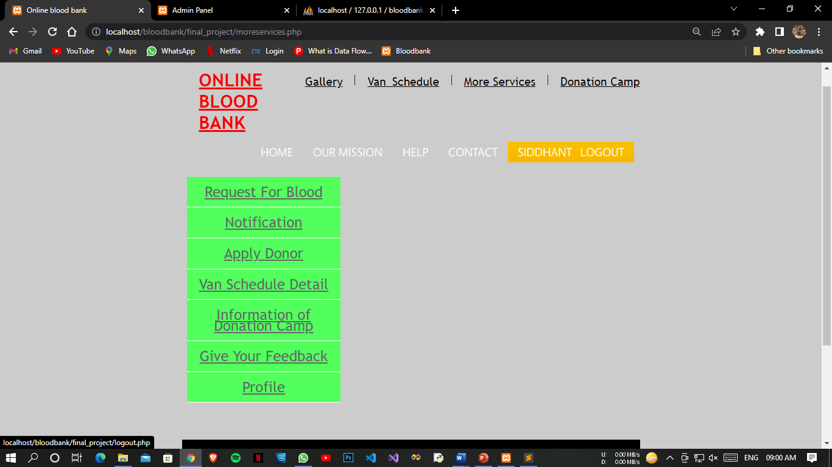*

*Logout Successfully*

*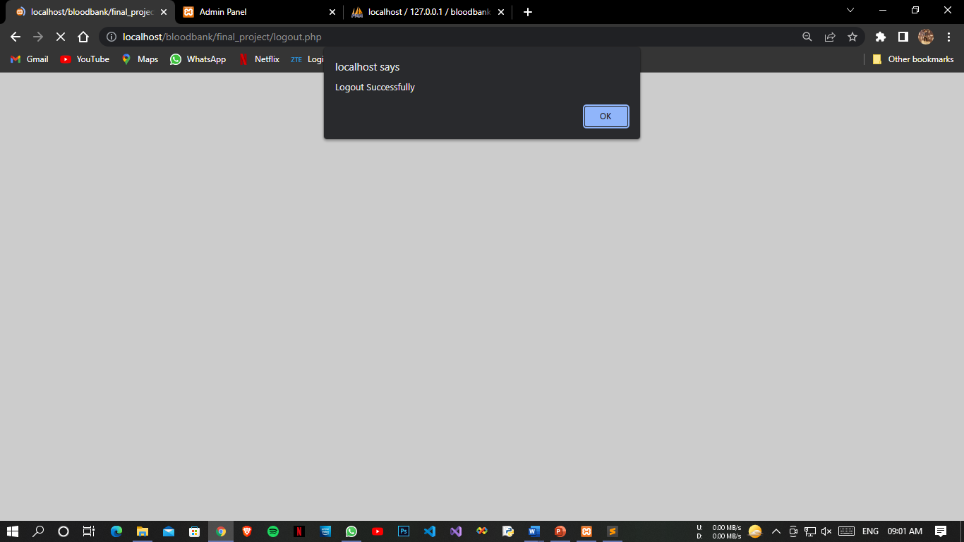*

*404 Error Page*

*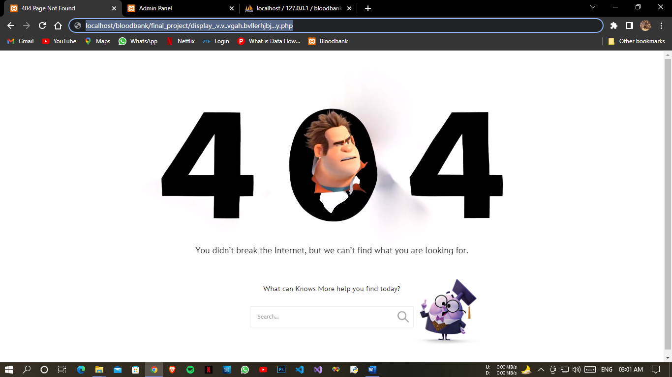*

***Guests***

*Gallery Page*

*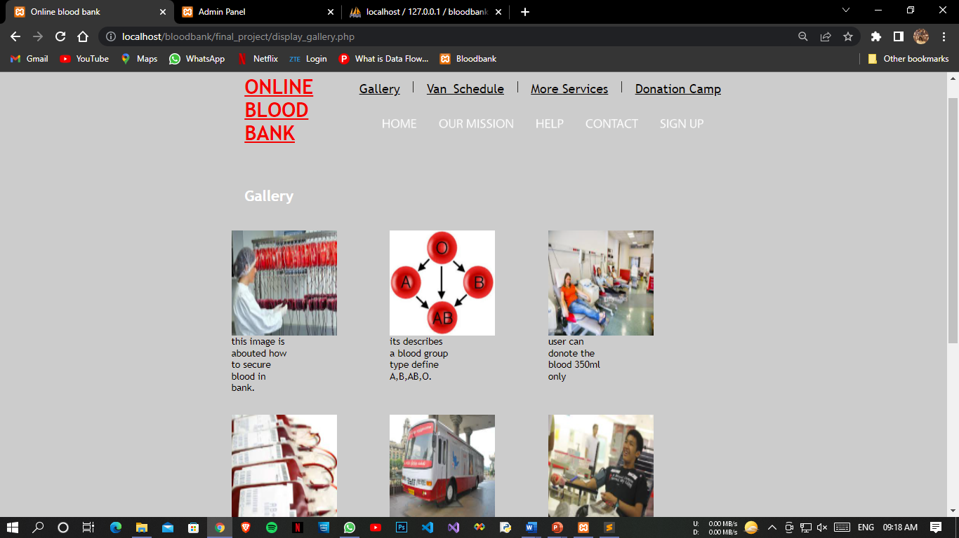*

*Gallery Page 2*

**

*Contact Page*

*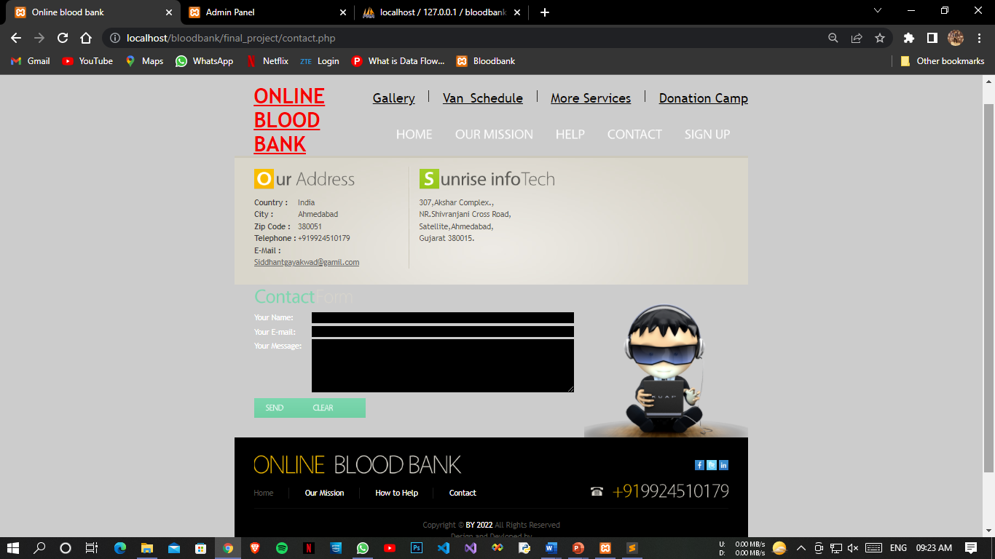*

***Admin***

*Login Page*

*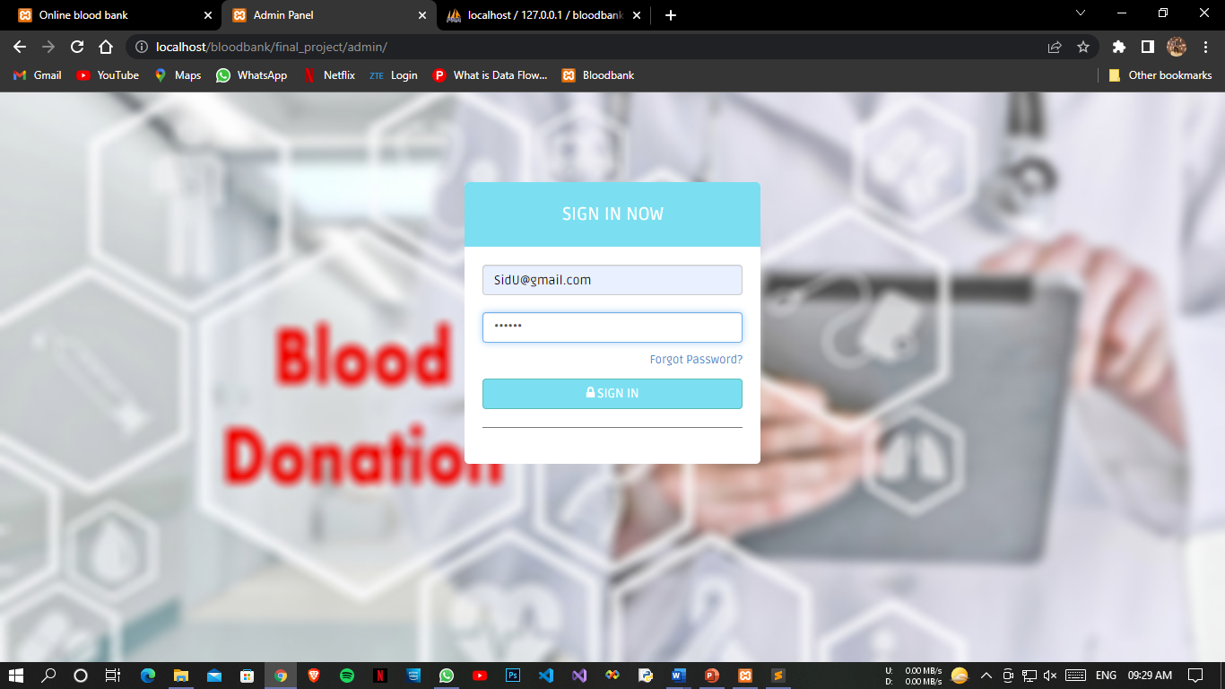*

*Admin Error Page*

*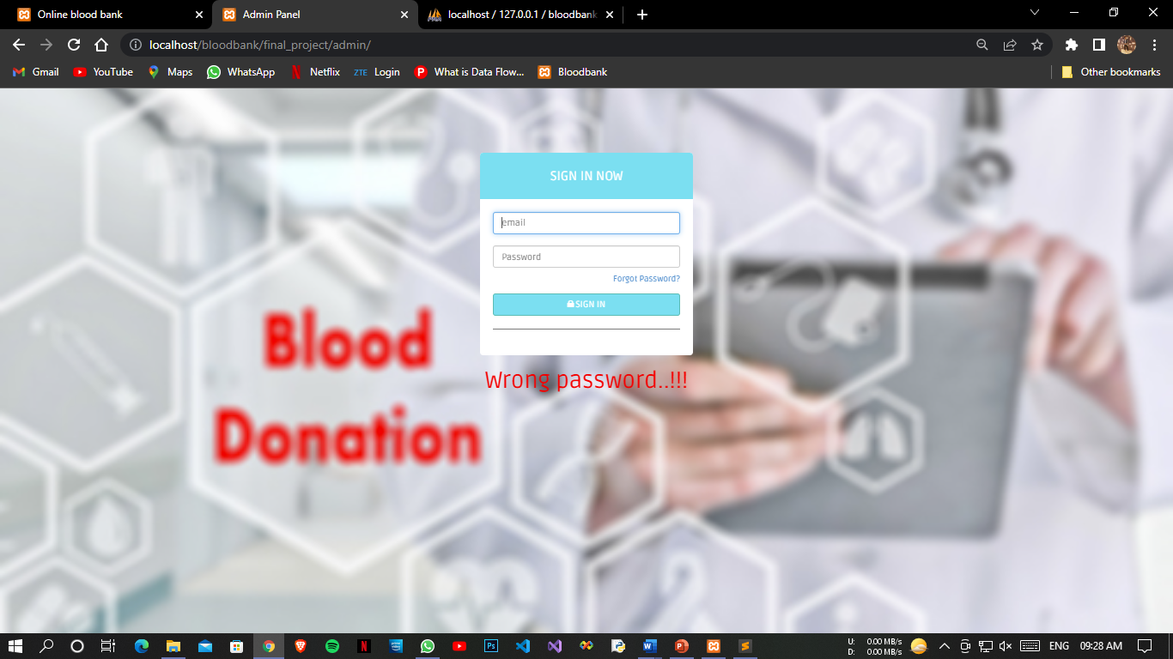*

*Login Successful*

*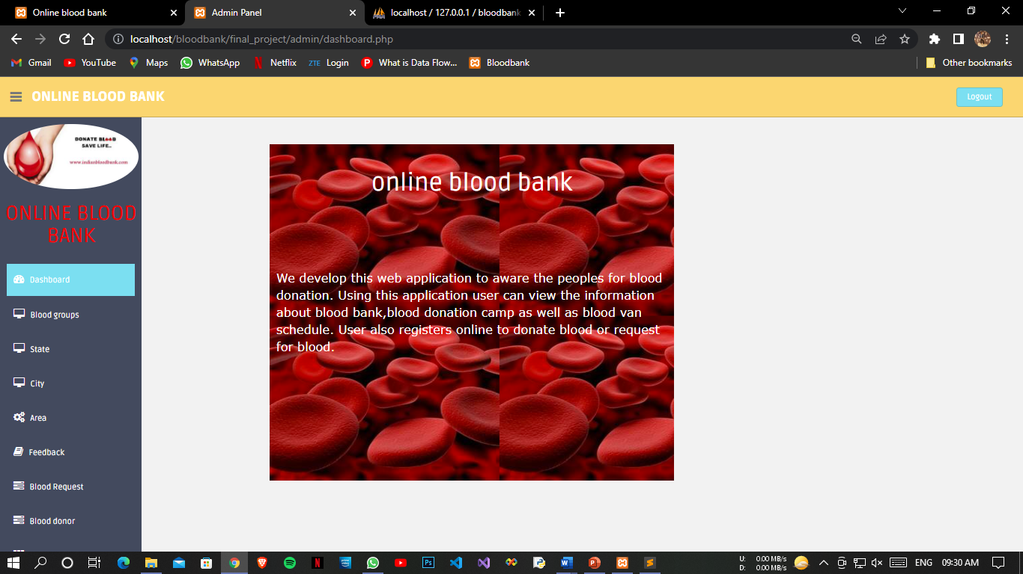*

*Blood Group Page*

*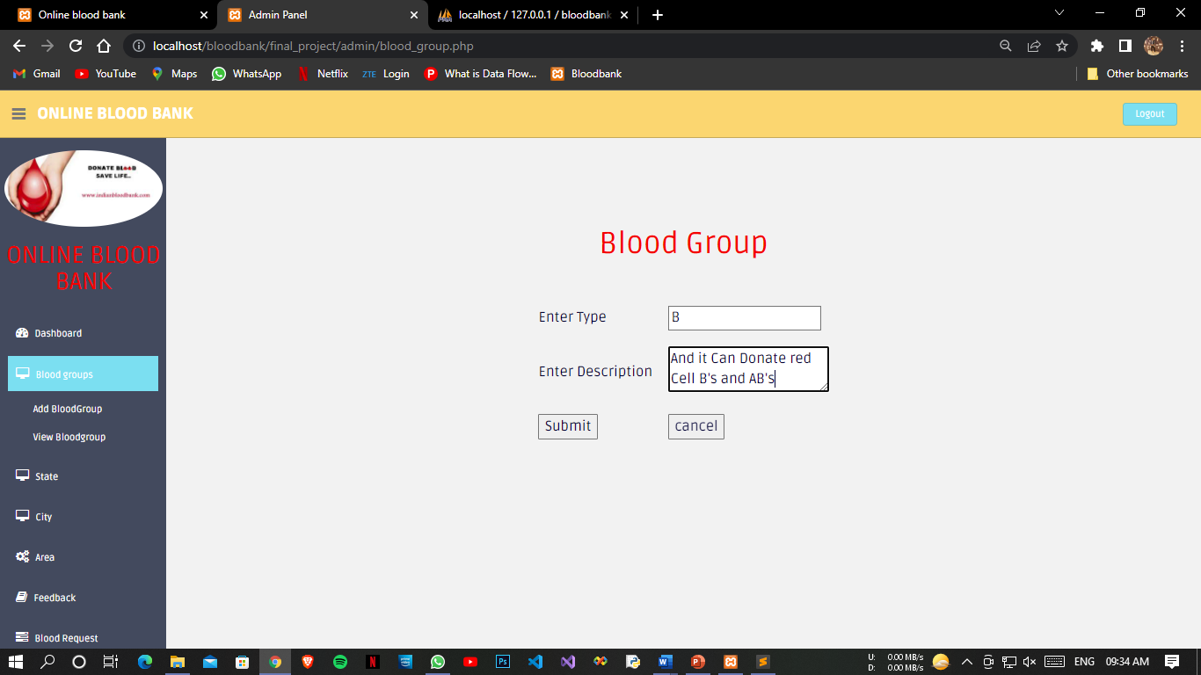*

*Added Successfully Blood Group*

*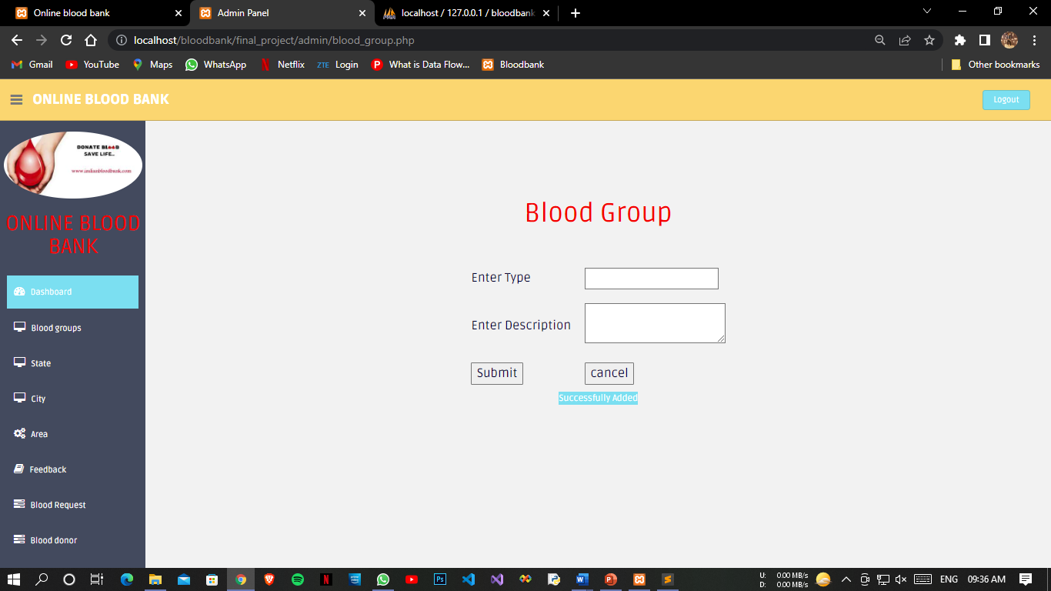*

*View Blood Group Page*

*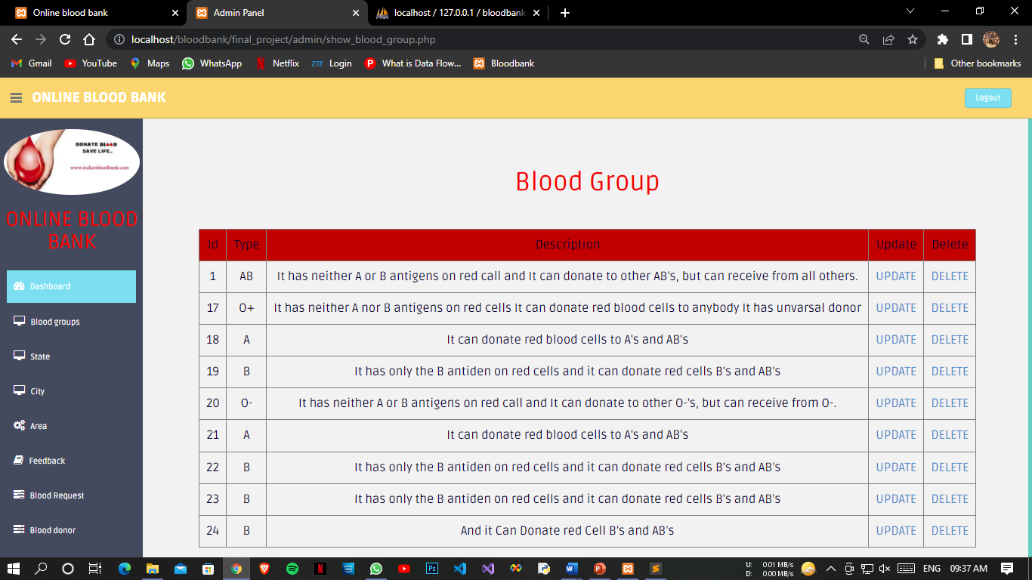*

*State Page*

*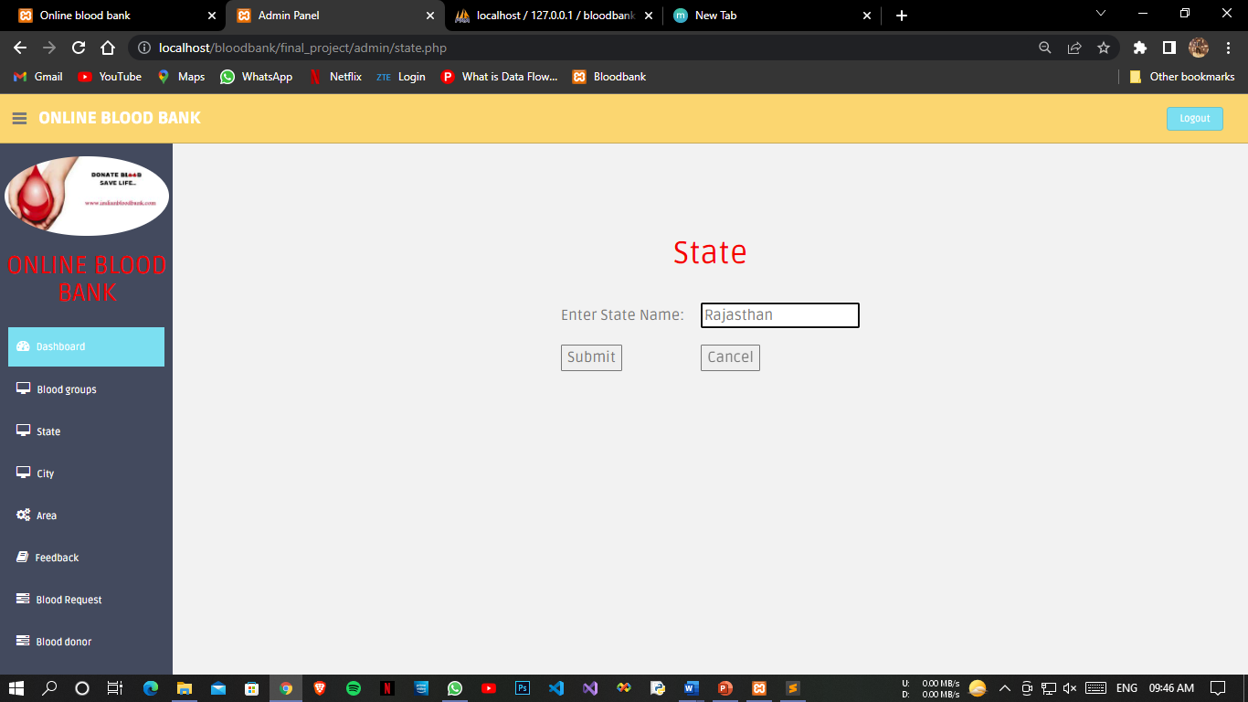*

*Added State Successfully*

*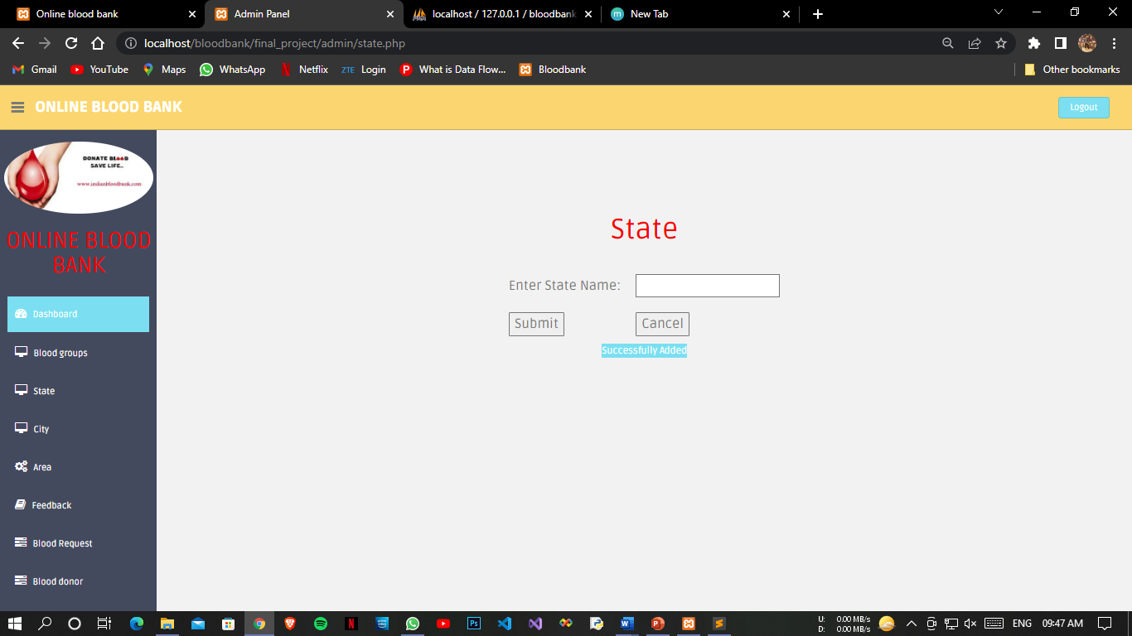*

*View State Page*

*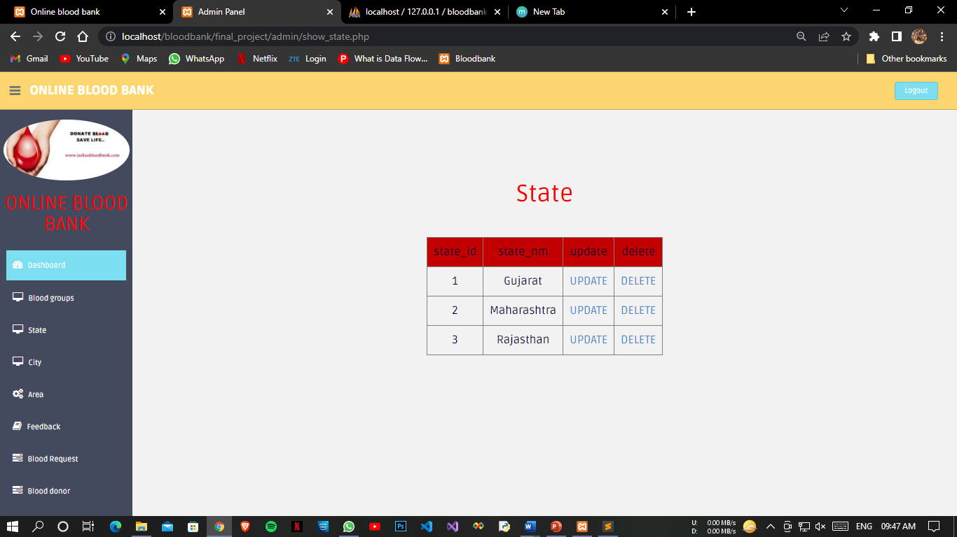*

*Add City 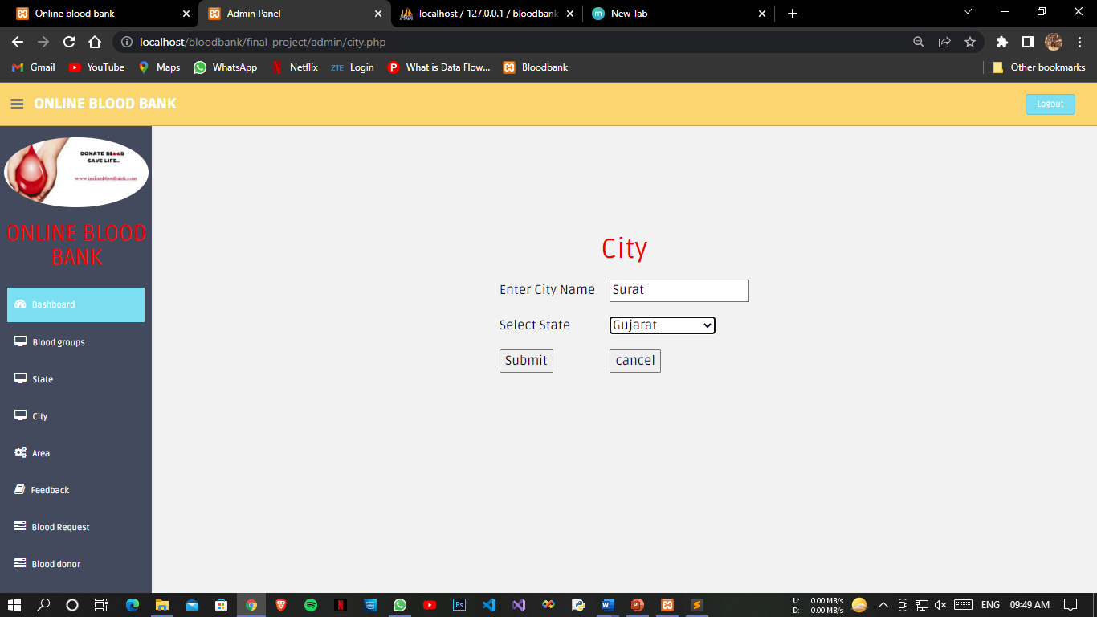*

*Added City Successful Page*

*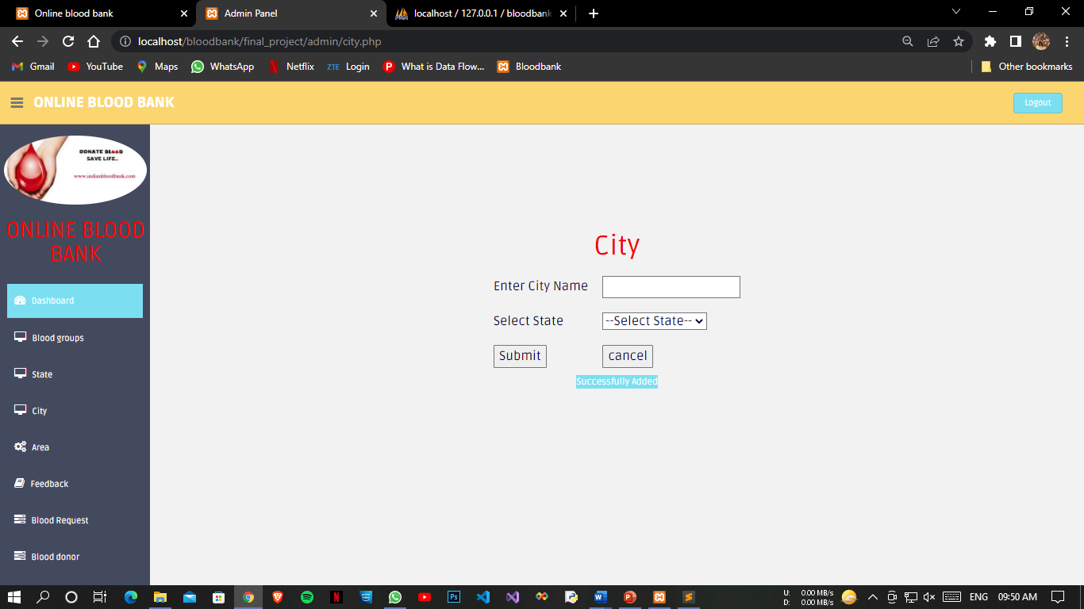*

*Updated City Page*

*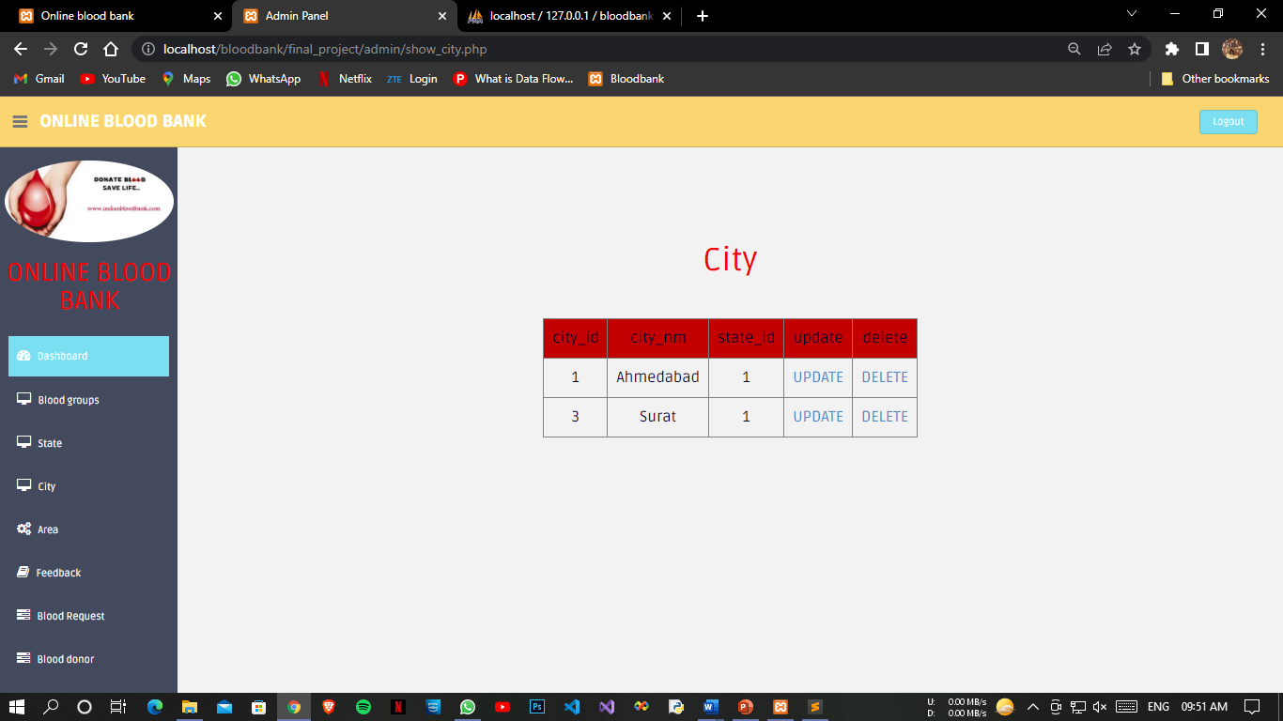*

*Area Page*

*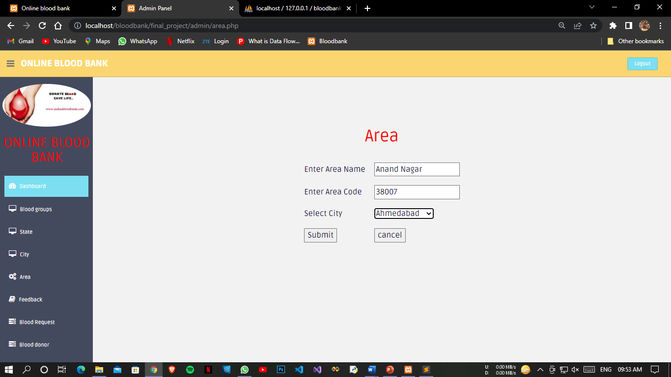*

*Added Area successful Page*

*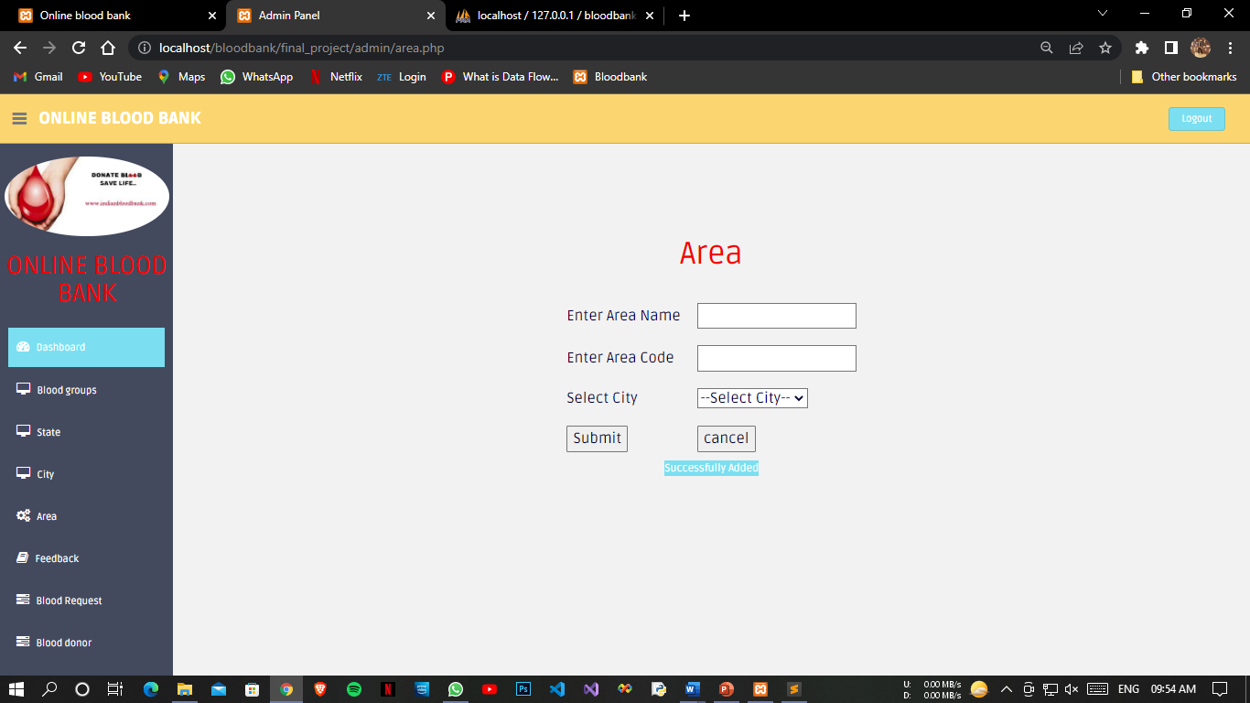*

*Updated Area Page*

*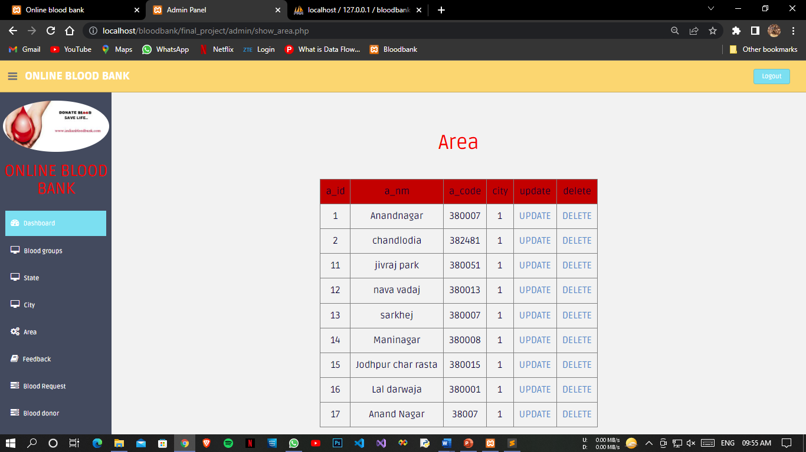*

*Feedback Page*

*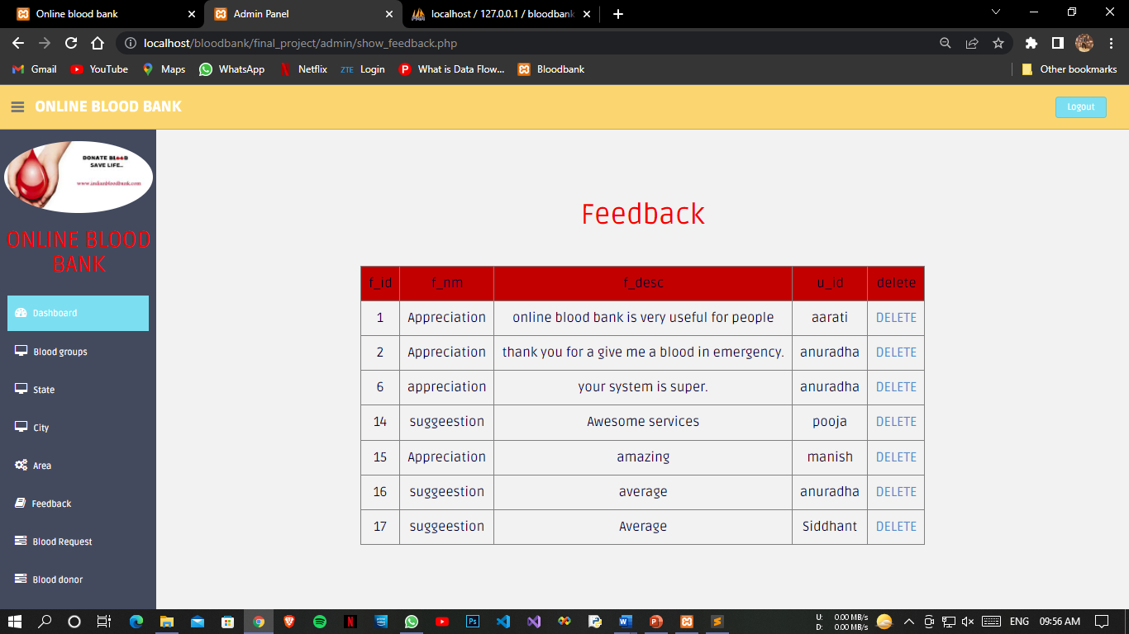*

*Blood Request Page*

*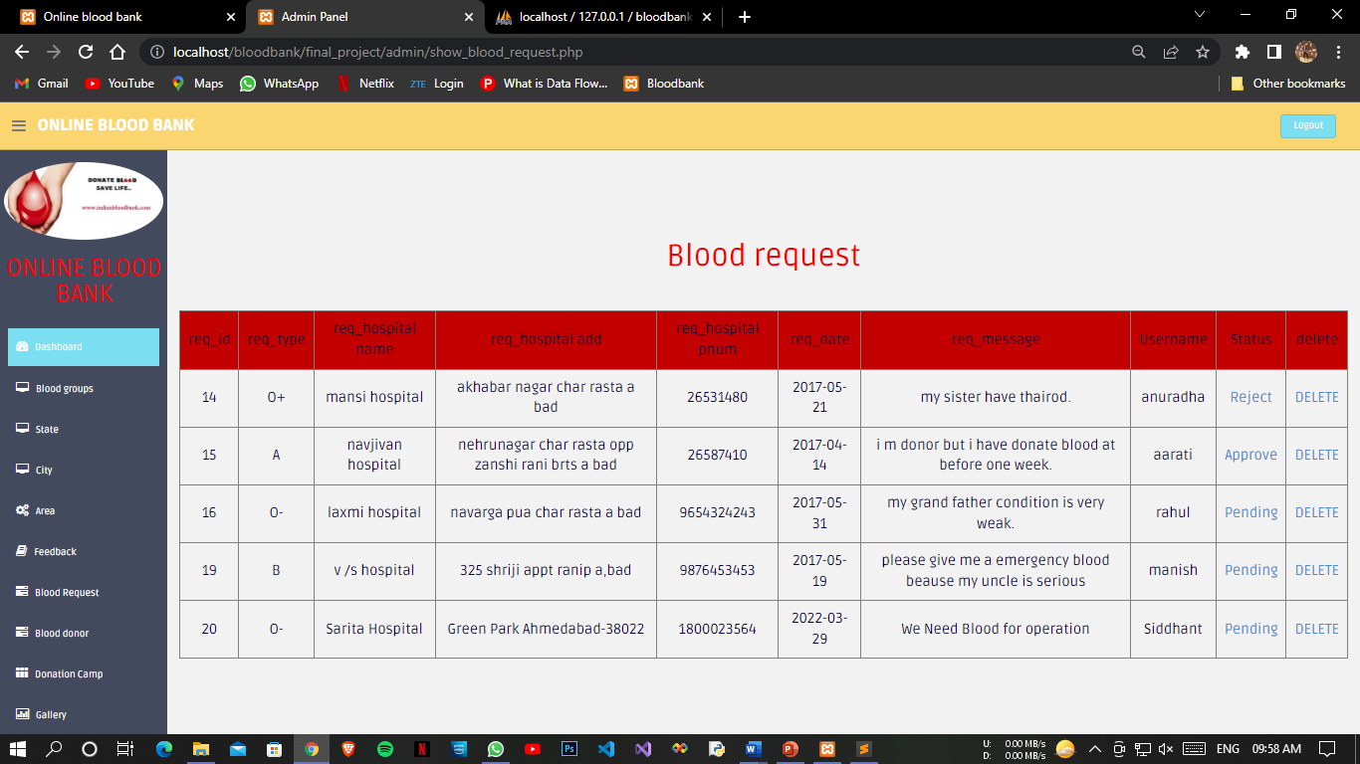*

*Change Request Status Page*

*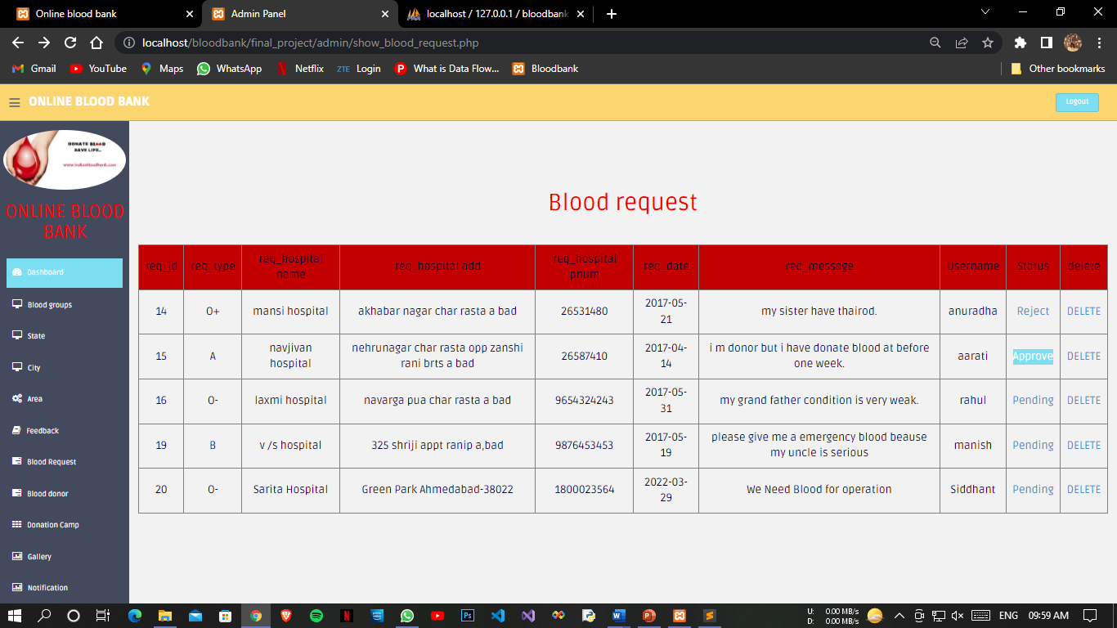*

*Reply For Blood Request Page*

*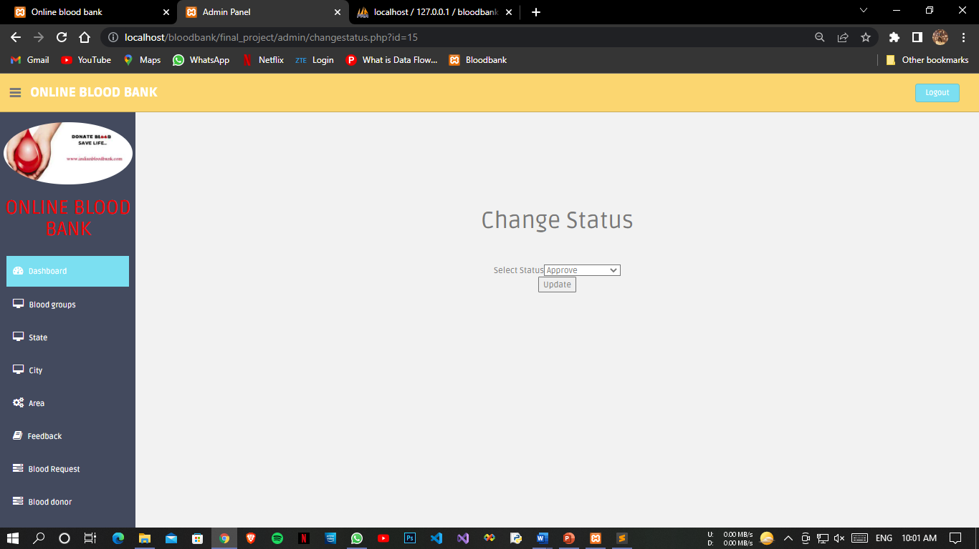*

*Delete Past Blood Requests Page*

*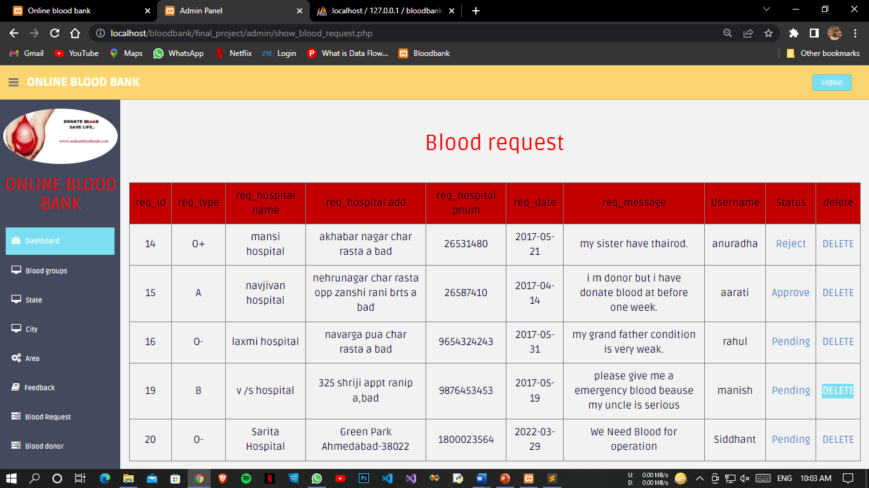*

*Successful Delete Blood Requests Page*

*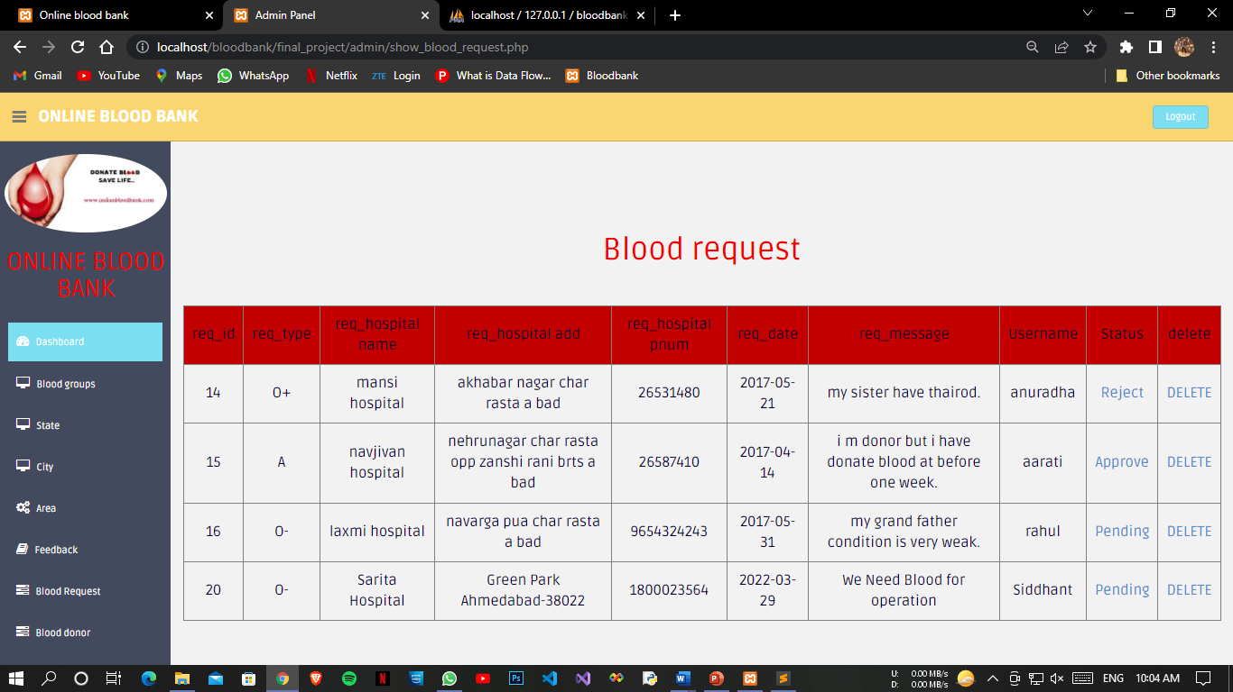*

*Blood Donors Page*

*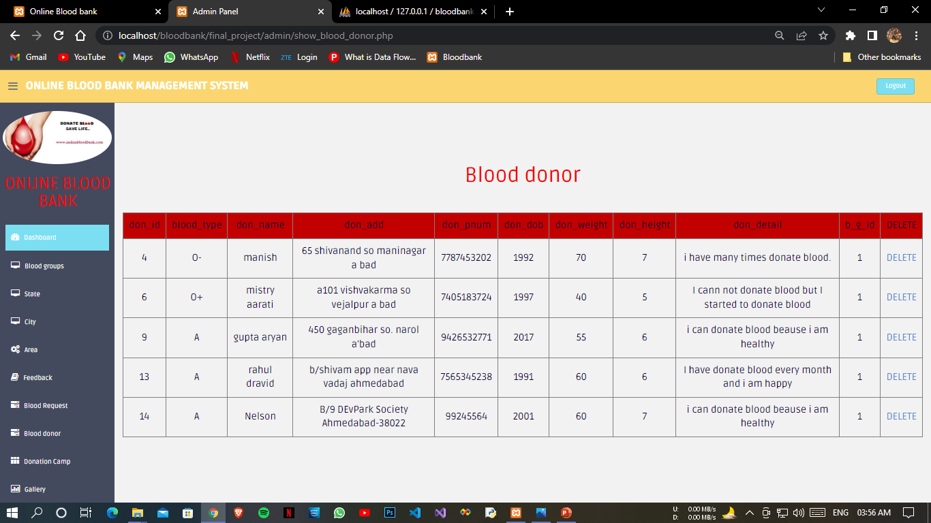*

*Add Blood Camp Page*

*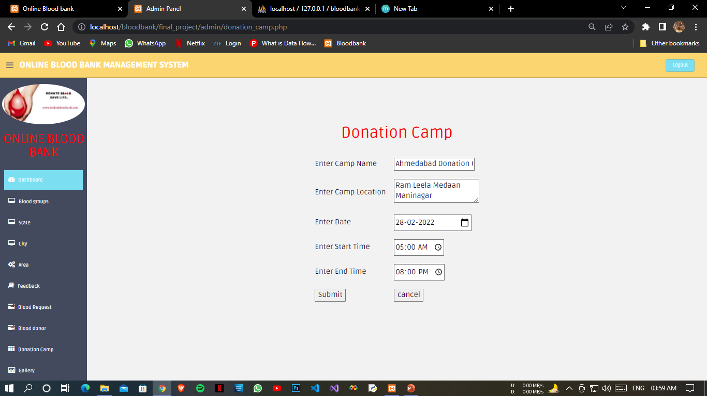*

*Successful Add Blood Camp Page*

*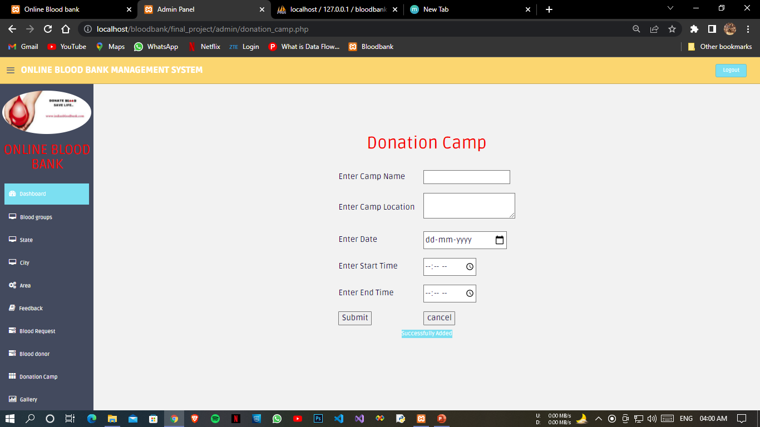*

*Blood Camp List Page*

*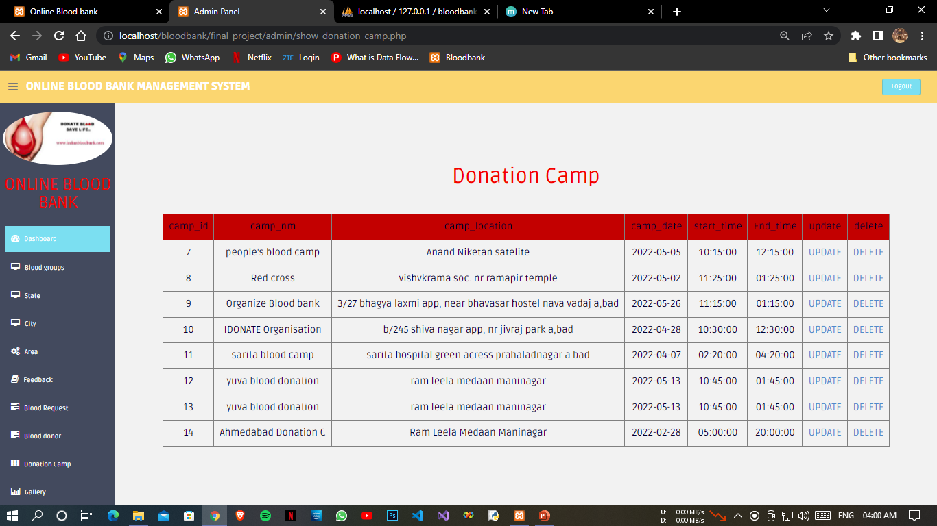*

*Add Gallery Page*

*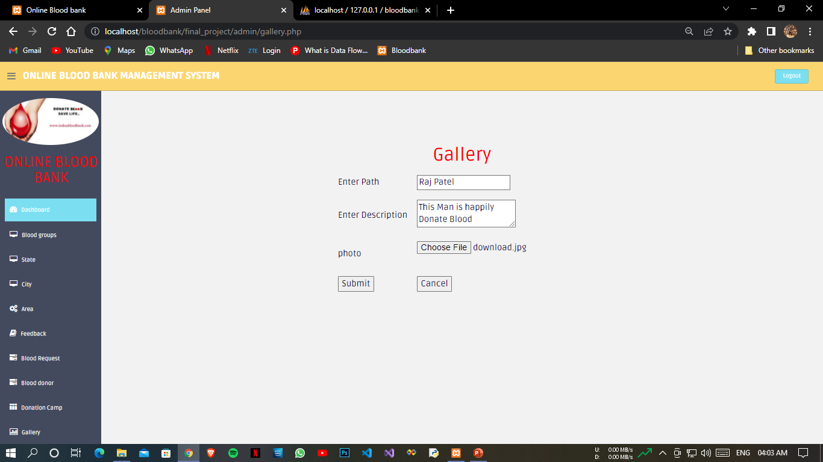*

*Successfully Added Gallery Page*

*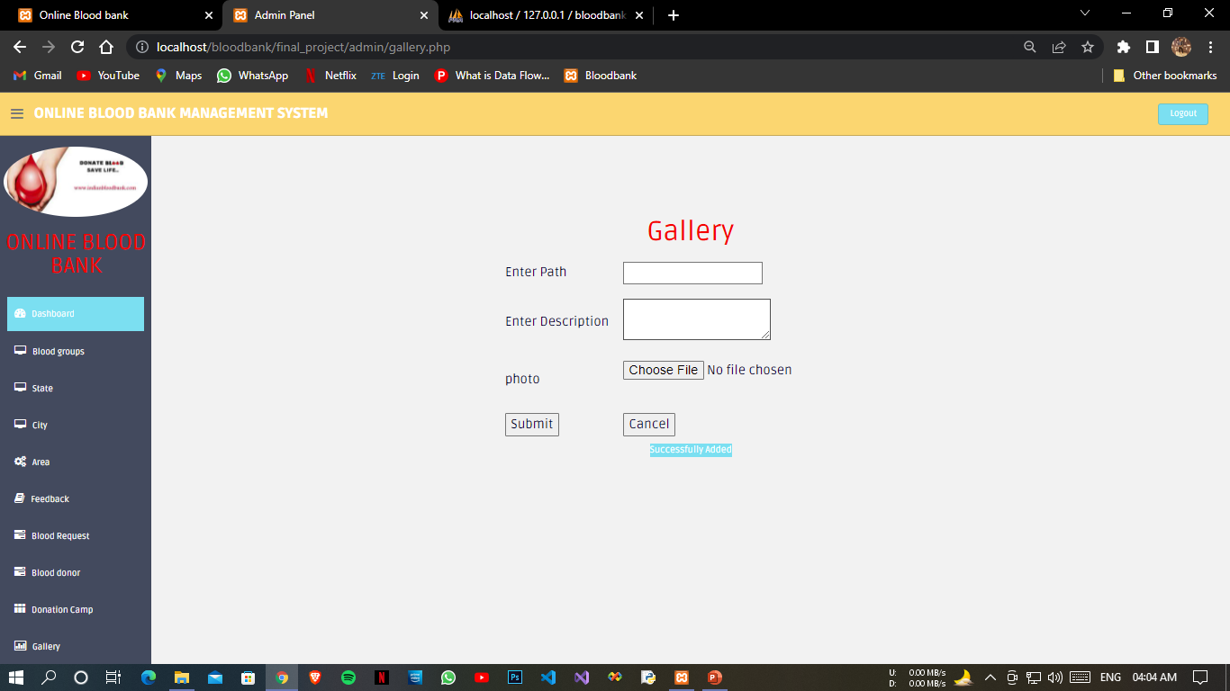*

*Updated Gallery Page*

*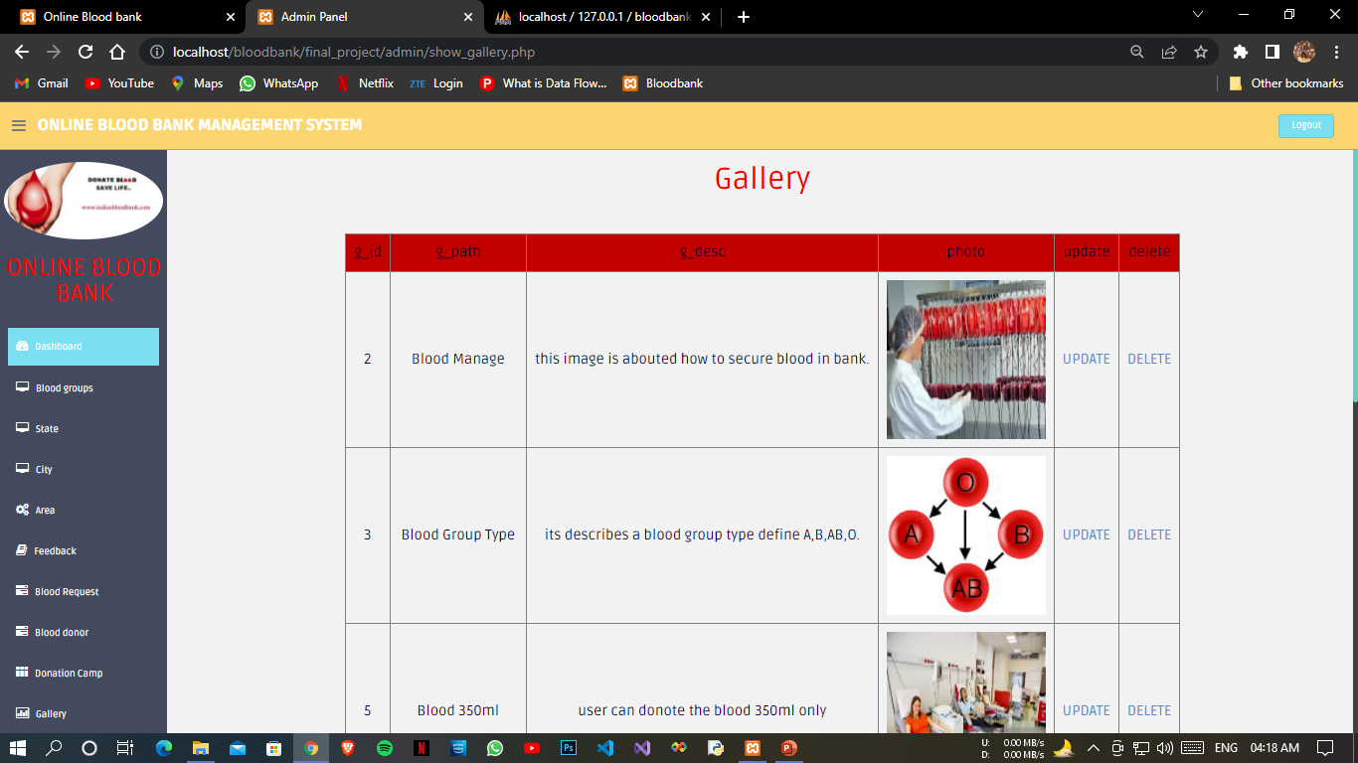*

*Updated Gallery Page 2*

*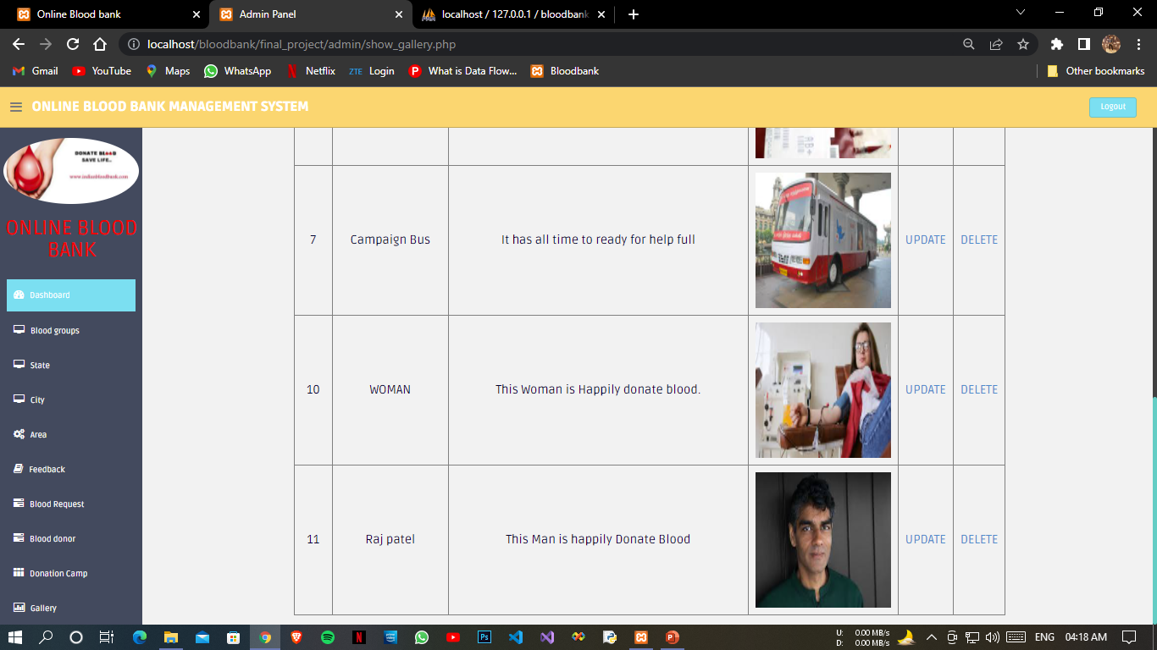*

*Adding Notification Details*

*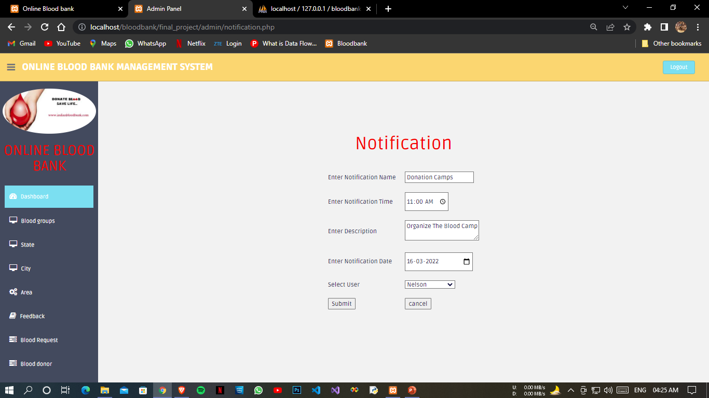*

*Successful Add Notification*

*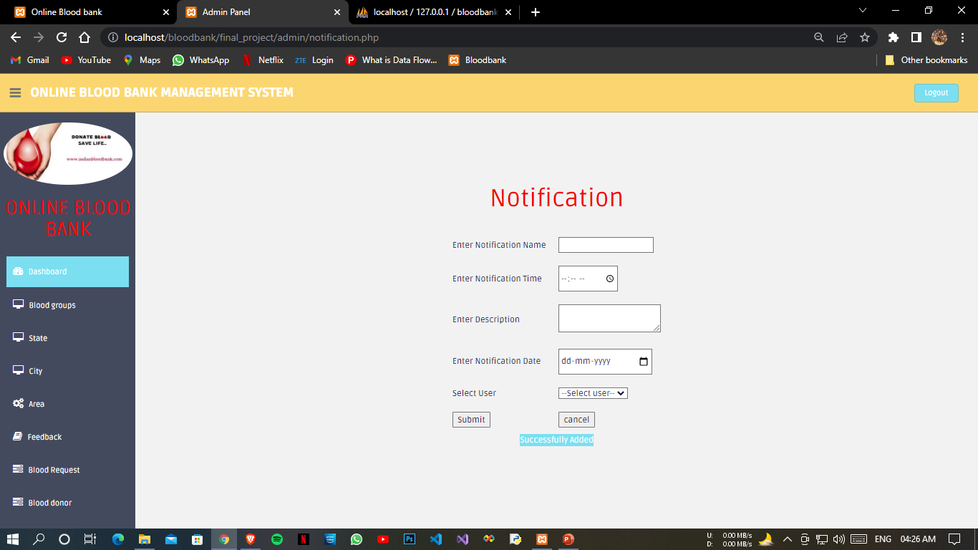*

*Updated Notification*

*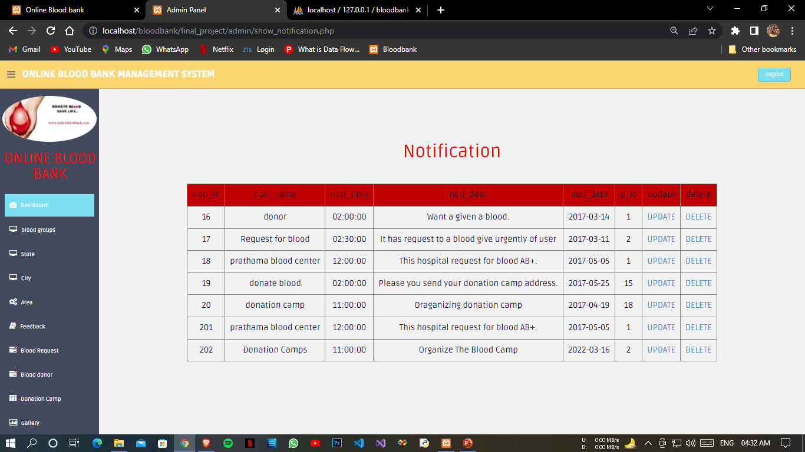*

*Adding Van Schedule Page*

*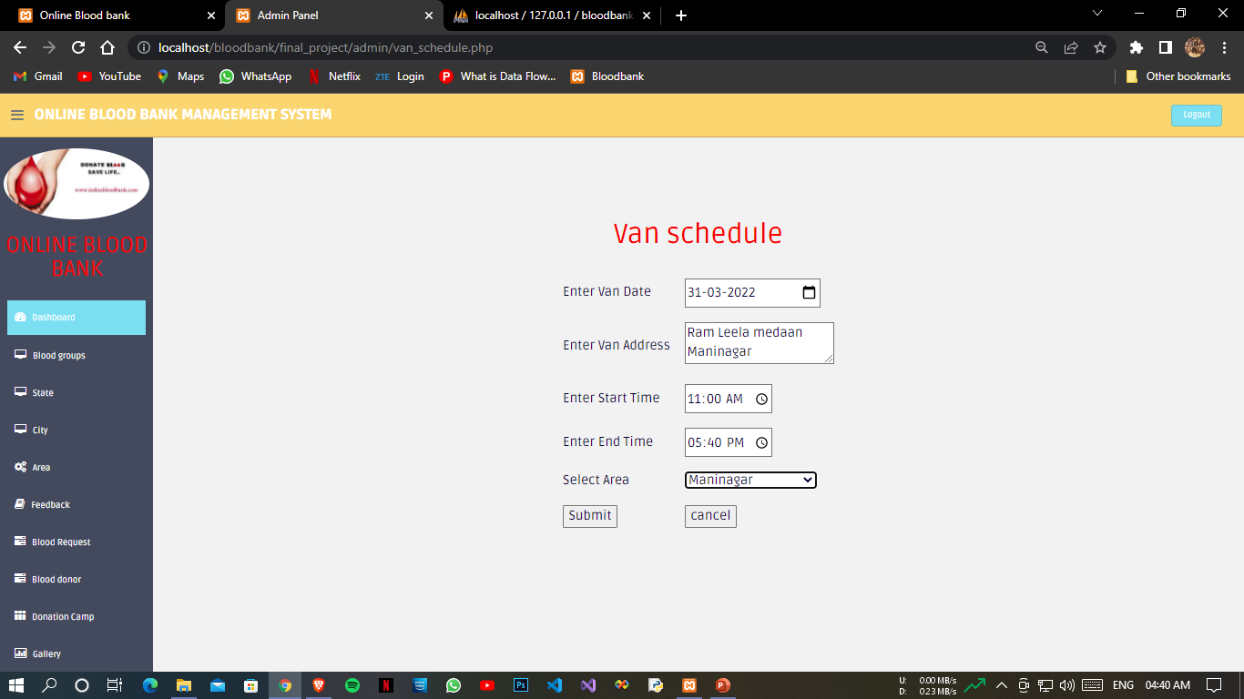*

*Successfully Added van Schedule*

*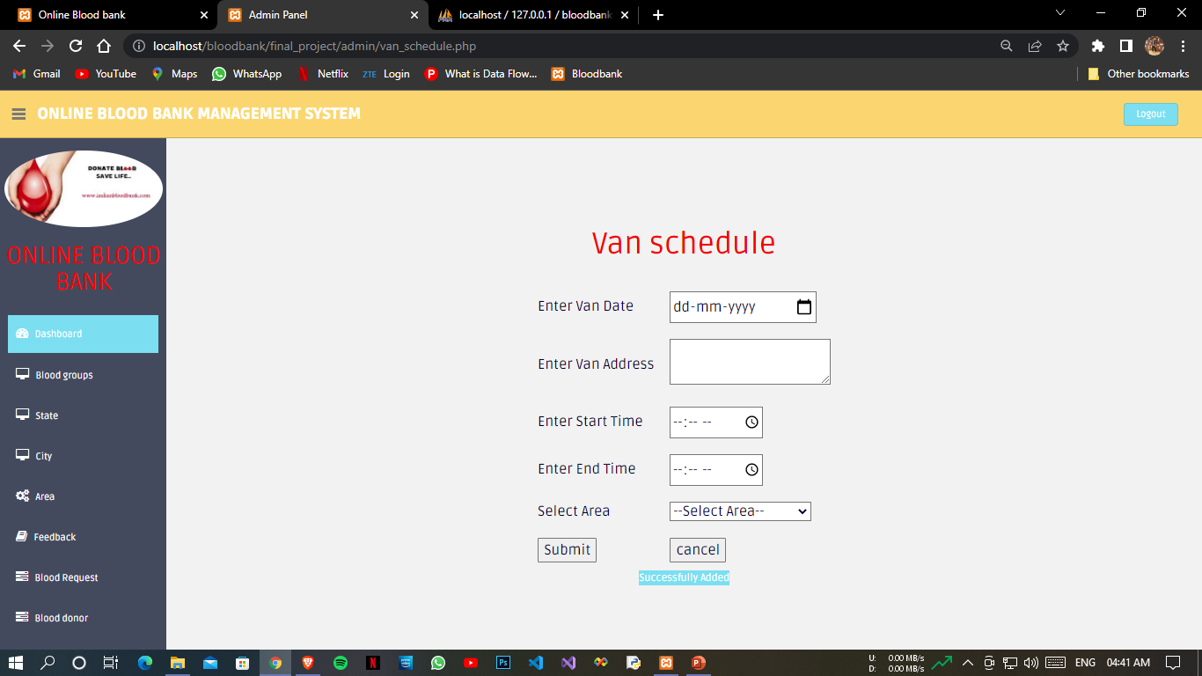*

*Updated van Schedule*

*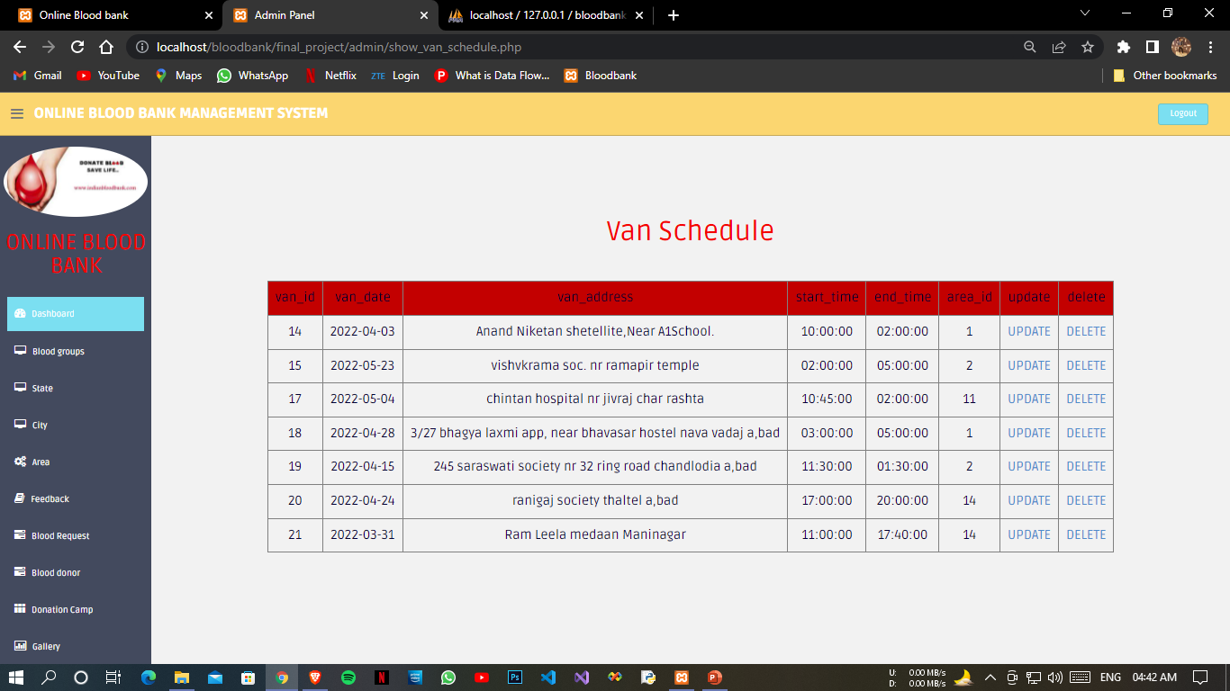*

*Added van Schedule Area*

*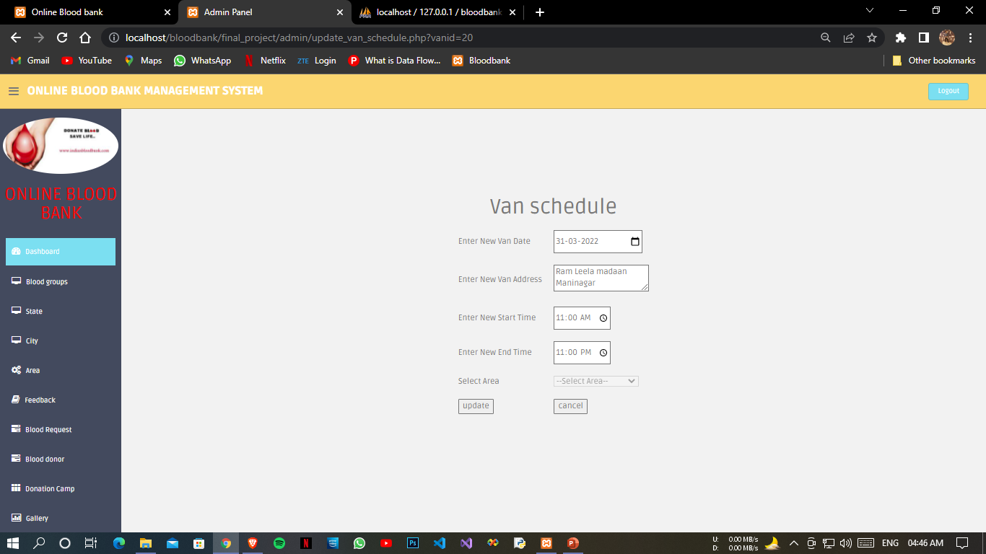*

*Updated van Schedule Area*

*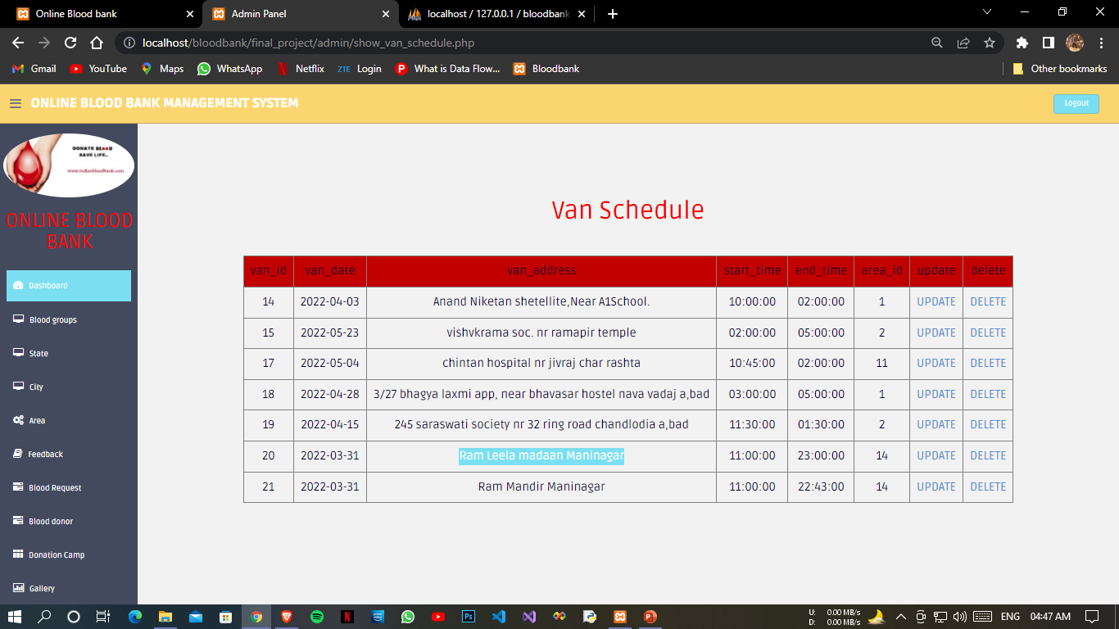*

*Updated Contact*

*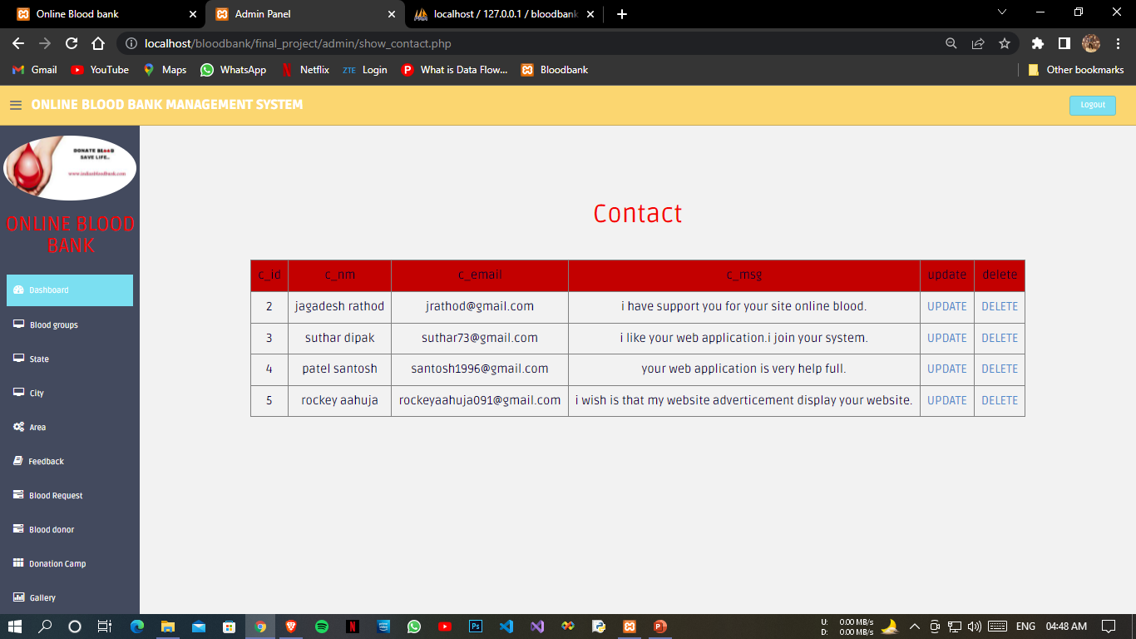*

*Manage User Page*

*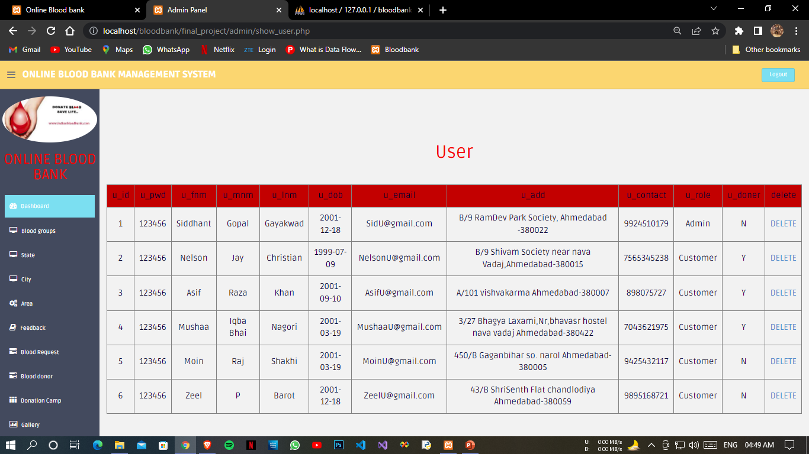*

*Deleting User*

*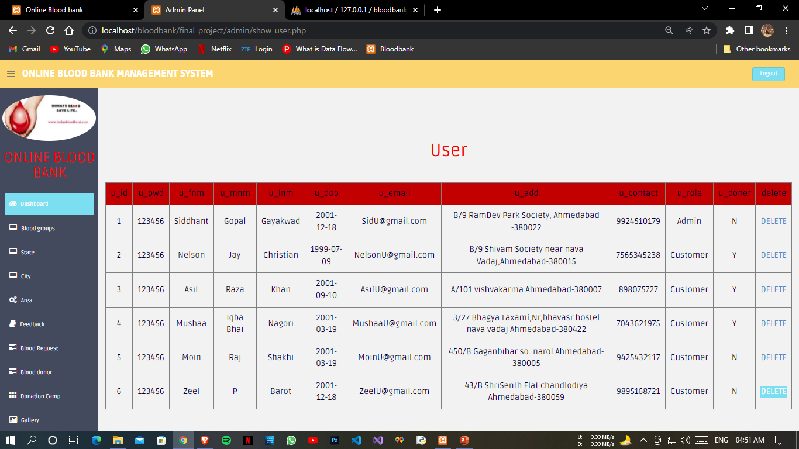*

*Delete User Successfully*

*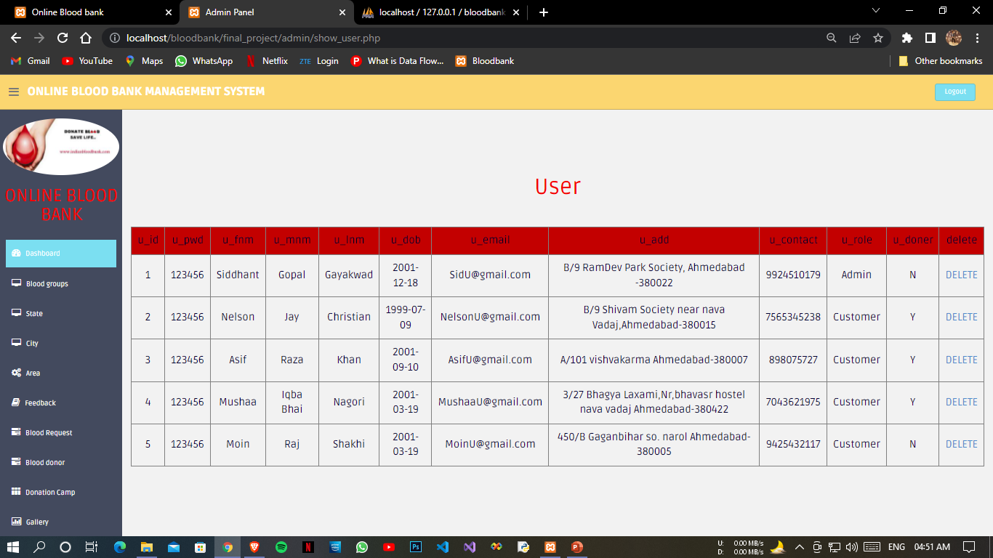*

***Report***

*Report Home*

*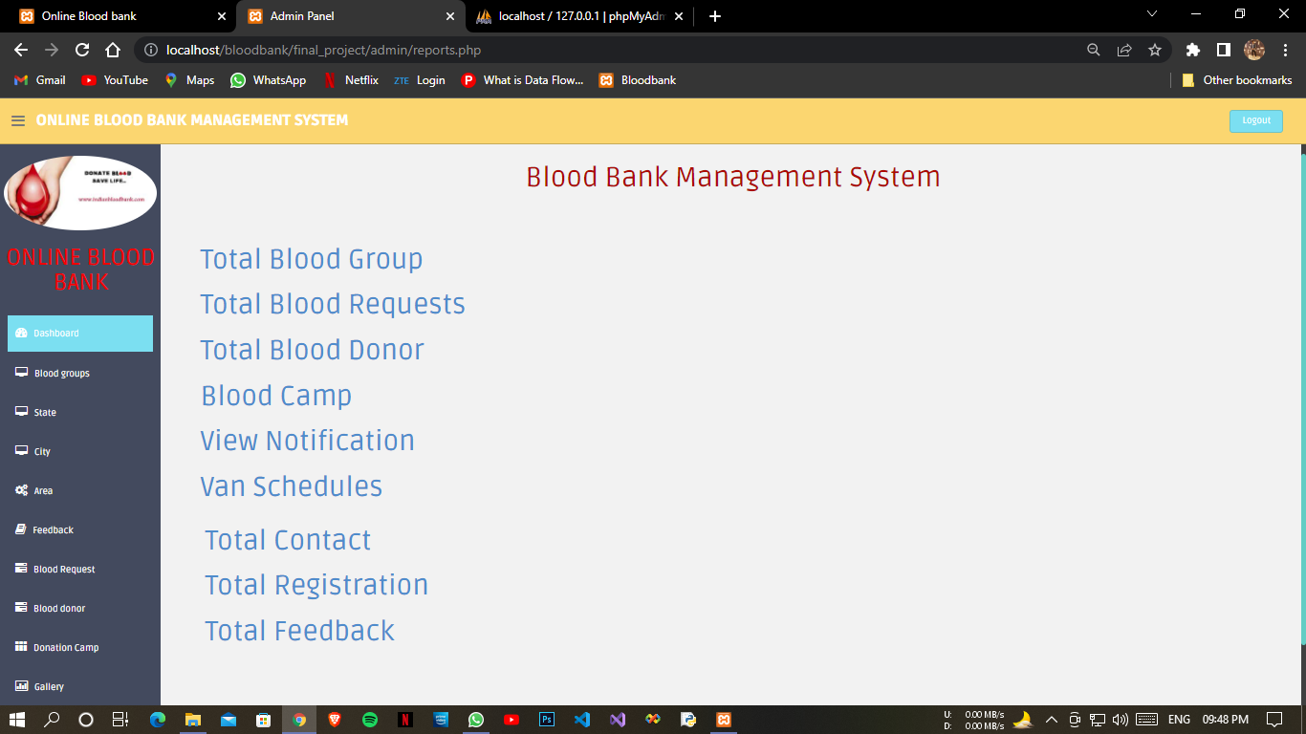*

*Blood Report 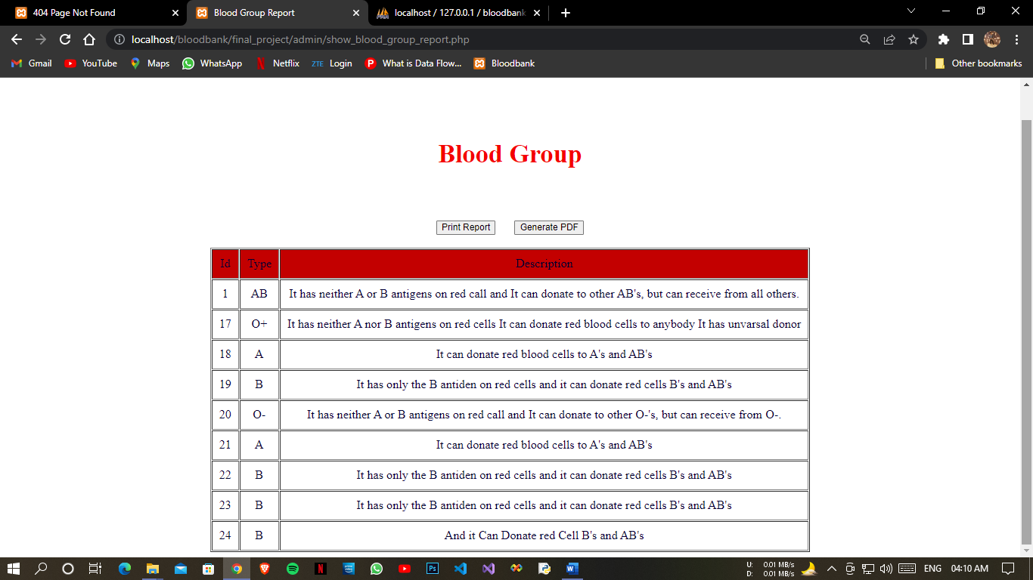*

*Blood Report Print*

*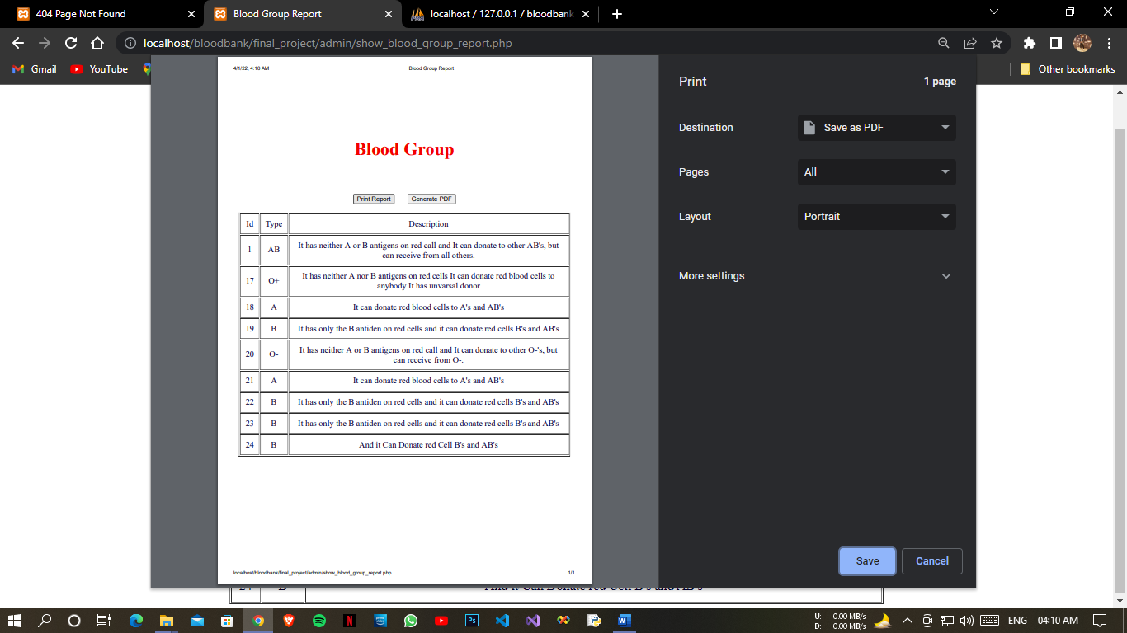*

*Generate Pdf*

****

*Blood Request Report*

*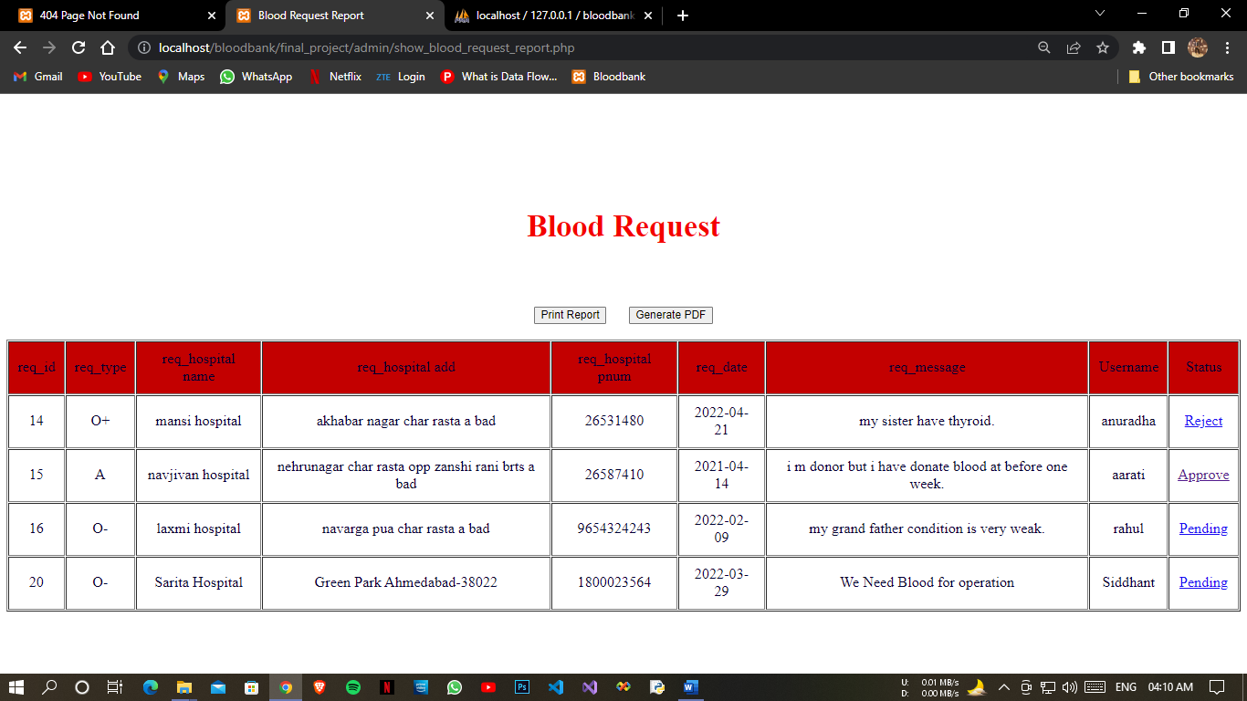*

*Blood Donor Report*

*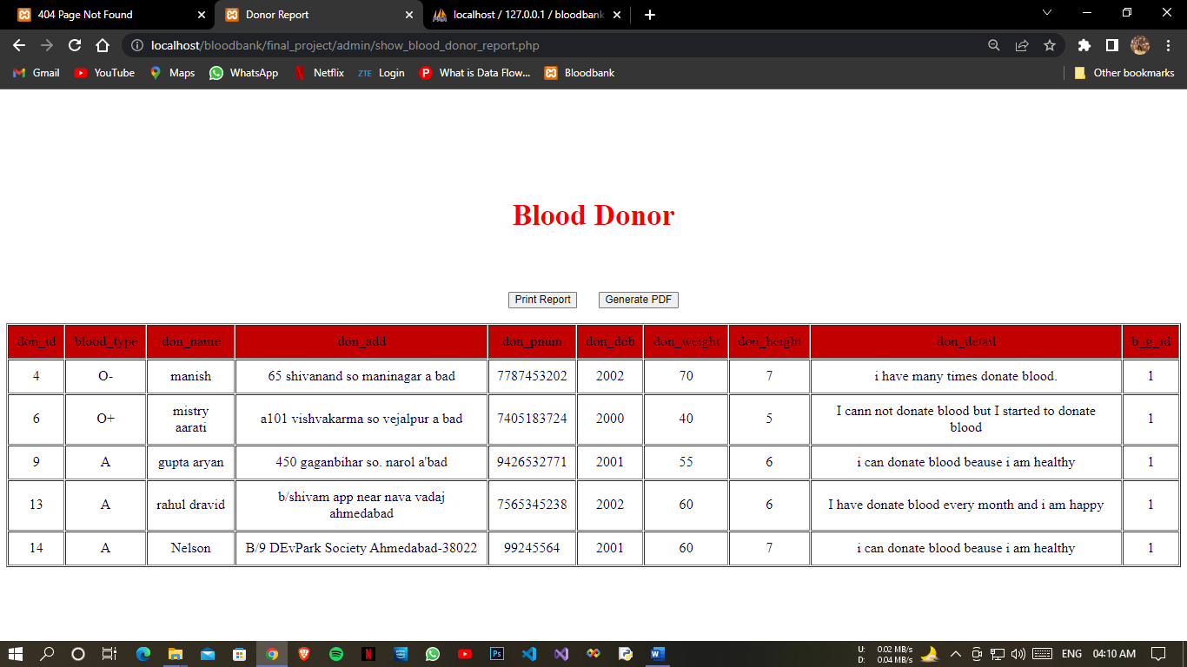*

*Blood Camp Report*

*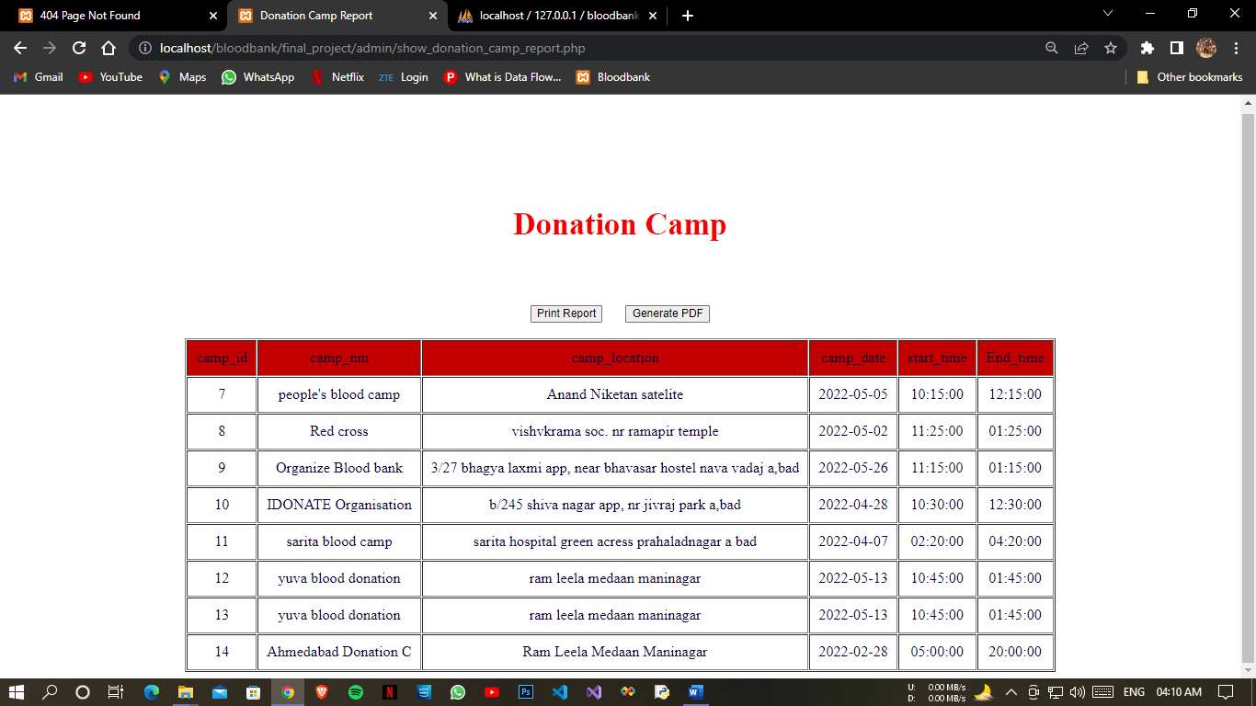*

*Notification Report*

*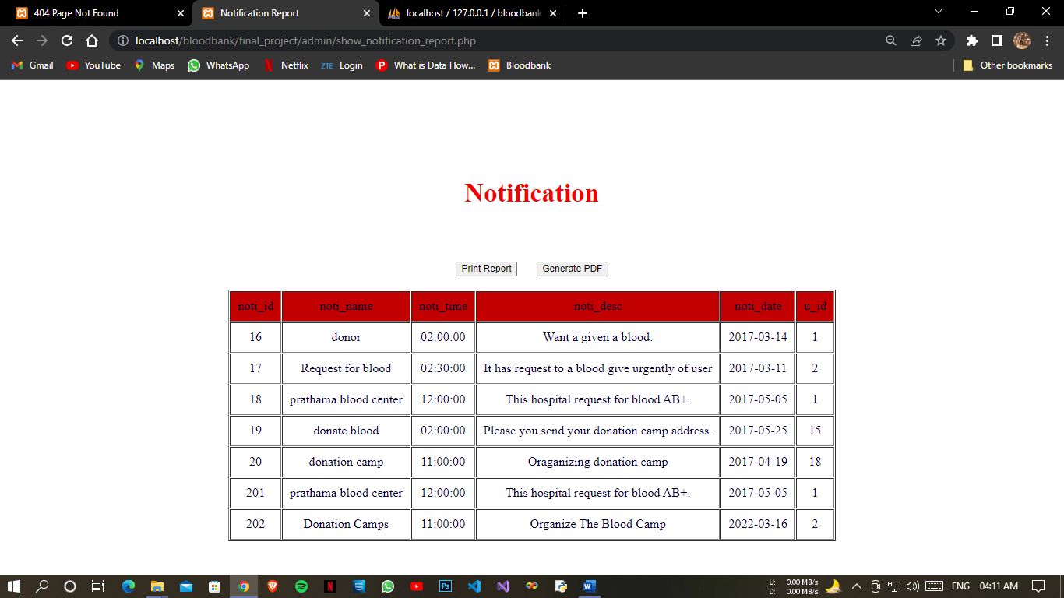*

*Van Schedule Report*

*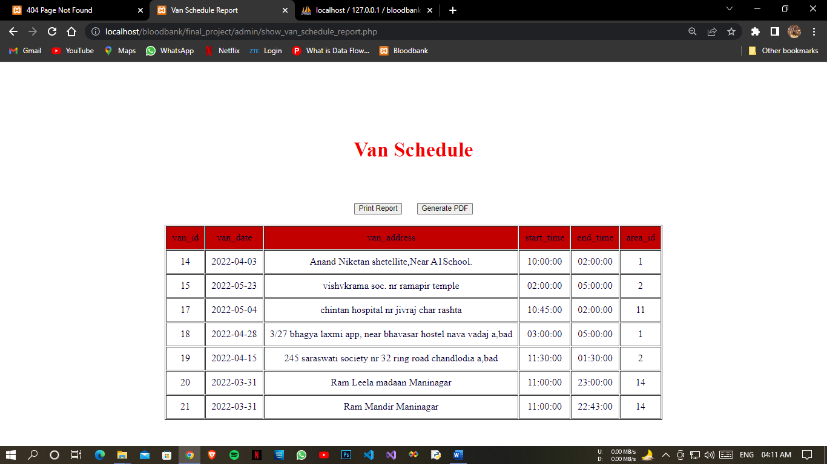*

*Contact Report*

*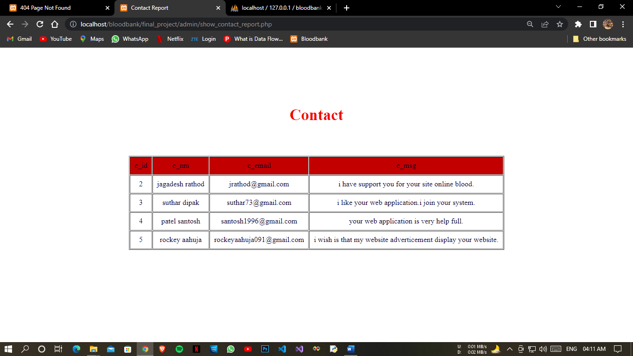*

*User Report*

*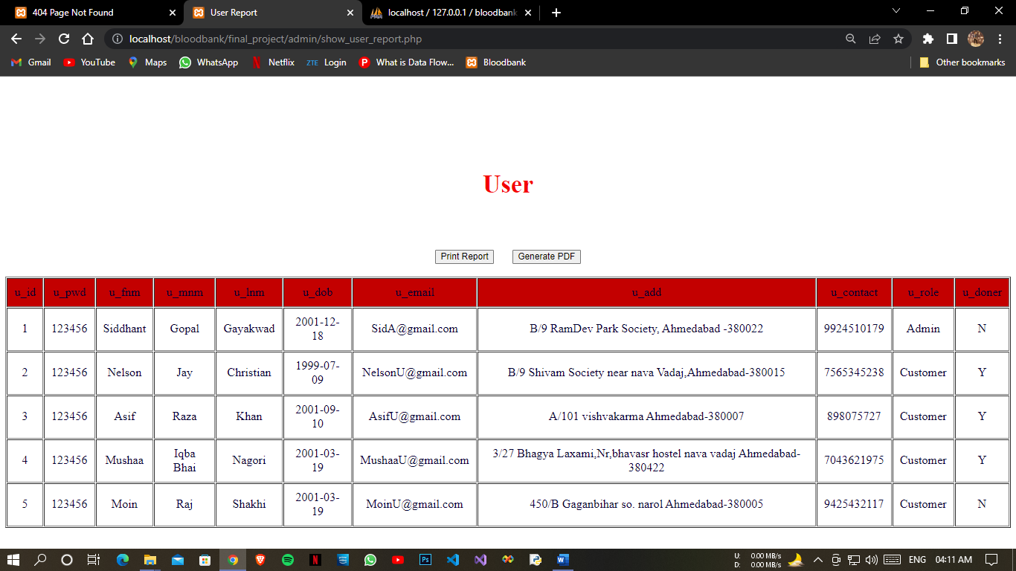*

*Feedback Report*

*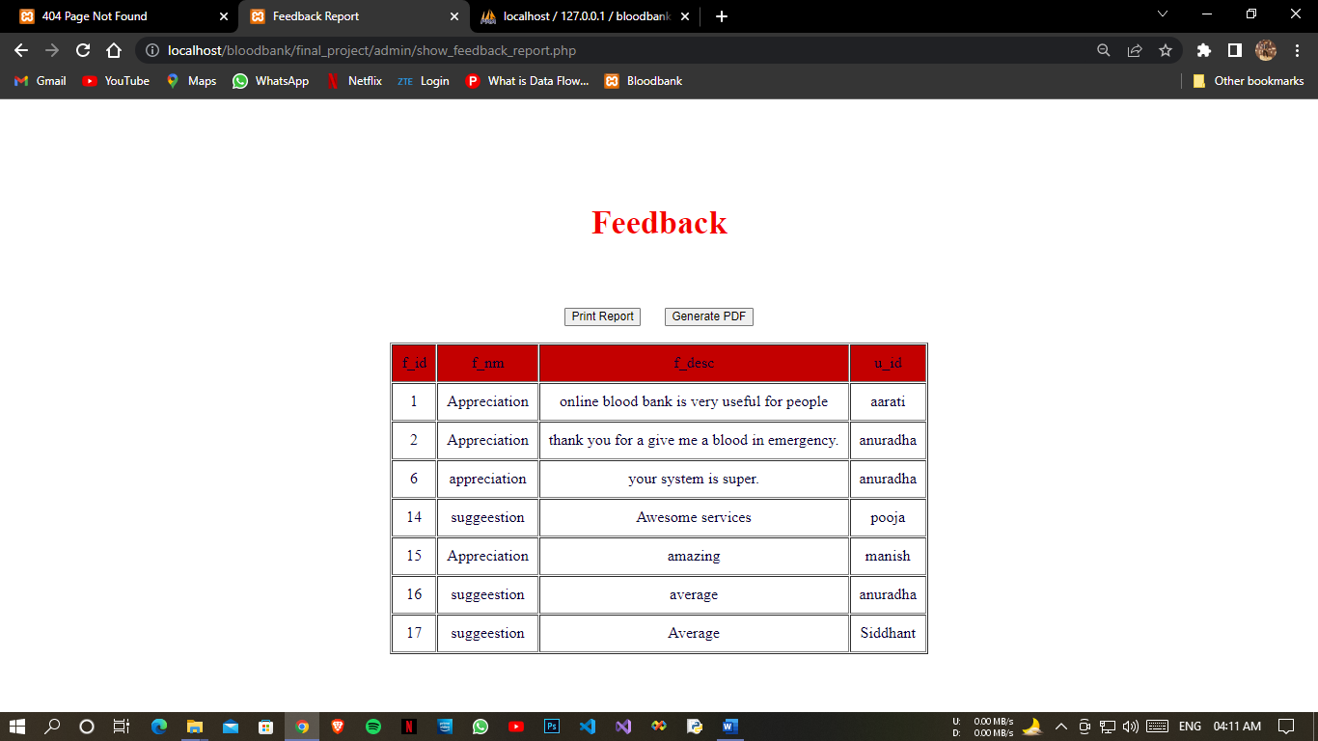*

**Future Enhancement**

* It gave us the requisite practical knowledge to supplement the already taught theoretical concepts thus making us more

competent as a computer engineer. The project from a

personal point of view also helped us in understanding

the following aspects of project development:

* The planning that goes into implementing a project.
* The importance of proper planning and an organized methodology.
* The key element of team spirit and co-ordination in a successful project.
* **BLOOD BANK MANAGEMENT** is a software application to build such a way that it should suits for all type of blood banks in **future.**
* One important future scope is availability of location-based blood bank details and extraction of location-based donor's detail, which is very helpful to the acceptant people. All the time the network facilities cannot be use. This time donor request does not reach in proper time, this can be avoided through adding some message sending procedure this will help to find proper blood donor in time. This will provide availability of blood in time.

**Conclusion**

* In Conclusion, Blood Bank Management System has to do with making appropriate effort to stop the rising problem to all manual Blood Bank operation in order to enhance the operation of such Blood Bank.
* In this project the software or system that can be used to aid all Blood Banks that is still operating manually have been successfully developed.
* Website mainly designs for Blood Bank purpose. The main aim of this application is to provide help for those people who are really Need for Blood for Patients, immediately Provides need Of Blood in near Hospitals.
* The goals achieved in following this approach: Automate the Blood management using online website to reduce the dependencies on natural resources and also provides a way communication between parents and teachers.
* The Blood Bank Management System is developed using PHP fully meets the objectives of the system which it has been developed. The system has reached a steady state where all bugs have been eliminated.
* The system is operated at a high level of efficiency and all the patient and user associated with the system understands its advantage. The system solves the problem. It was intended to solve as requirement specification.

Thanks to all our Internal and External Faculties.

Written By: -

Gayakwad Siddhant G

Sharma Harsh

Satodiya Shrey

**Bibliography**

* **Reference Books**:
* Fundamentals of Database System
* **Reference Websites**
* [Google](https://www.google.co.in/)
* [Wikipedia](https://www.wikipedia.org/)
* <https://www.scribd.com>
* [https://www.slideshare.net](https://www.slideshare.net/)
* <https://www.google.com>

